|  |  |
| --- | --- |
|  |  |
| LIBRARY **MANAGEMENT SYSTEM** |  |
|  |  |
|  | PRESENTED BY:PUJA K |
|  |  |

**What is SQL?**

SQL (Structured Query Language) is a programming language which is used to manage data stored in relational databases like MySQL, MS Access, SQL Server, Oracle, Sybase, Informix, Postgres etc. and it is pronounced as S-Q-L or sometimes as See-Quell.

This database language is mainly designed for maintaining the data in relational database management systems. It is a special tool used by data professionals for handling structured data (data which is stored in the form of tables).

**SQL Commands**

* SQL commands are instructions. It is used to communicate with the database. It is also used to perform specific tasks, functions, and queries of data.
* SQL can perform various tasks like create a table, add data to tables, drop the table, modify the table, set permission for users.

**Types of SQL Commands**

1. Data Definition Language (DDL)
2. Data Manipulation Language (DML)
3. Data Control Language (DCL)
4. Transaction Control Language (TCL)
5. Data Query Language (DQL/DSL/DRL)

**1. Data Definition Language (DDL)**

* DDL changes the structure of the table like creating a table, deleting a table, altering a table, etc.
* All the command of DDL are auto-committed that means it permanently save all the changes in the database.

Here are some commands that come under DDL:

* CREATE
* ALTER
* DROP
* TRUNCATE
* RENAME
* **CREATE:** It is used to create a new table in the database.
* **ALTER:** It is used to alter the structure of the database. This change could be either to modify the characteristics of an existing attribute or probably to add a new attribute.
* **DROP:** It is used to delete both the structure and record stored in the table.
* **TRUNCATE:** It is used to delete all the rows from the table.
* **RENAME:** It is used to change the name of the table or a database object.

### **2. Data Manipulation Language (DML)**

* DML commands are used to modify the database. It is responsible for all form of changes in the database.
* The command of DML is not auto-committed that means it can't permanently save all the changes in the database. They can be rollback.

Here are some commands that come under DDL:

* INSERT
* UPDATE
* DELETE
* **INSERT:** The INSERT statement is a SQL query. It is used to insert data into the row of a table.
* **UPDATE:** This command is used to update or modify the value of a column in the table.
* **DELETE:** It is used to remove one or more row from a table.

**3. Data Control Language (DCL)**

* DCL commands are used to grant and take back authority from any database user.

Here are some commands that come under DDL:

* GRANT
* REVOKE
* **GRANT:** It is used to give user access privileges to a database.
* **REVOKE:** It is used to take back permissions from the user.

**4. Transaction Control Language (TCL)**

* TCL commands can only use with DML commands like INSERT, DELETE and UPDATE only.
* These operations are automatically committed in the database that's why they cannot be used while creating tables or dropping them.

Here are some commands that come under DDL:

* COMMIT
* ROLLBACK
* SAVEPOINT
* **COMMIT:** Commit command is used to save all the transactions to the database permanently.
* **ROLLBACK:** Rollback command is used to undo transactions that have not already been saved to the database.
* **SAVEPOINT:** It is used to roll the transaction back to a certain point without rolling back the entire transaction.

**5. Data Query Language (DQL)**

* DQL is used to fetch/retrieve the data from the database.

Here are some commands that come under DDL:

* SELECT
* **SELECT:** It is used to select the attribute based on the condition described by WHERE clause.

**Database Management System**

* Database management system is a software which is used to manage the database. For example: [MySQL](https://www.javatpoint.com/mysql-tutorial), [Oracle](https://www.javatpoint.com/oracle-tutorial), etc. are a very popular commercial database which is used in different applications.

**RDBMS (Relational Database Management System)**

* All modern database management systems like SQL, MS SQL Server, IBM DB2, ORACLE, My-SQL, and Microsoft Access are based on RDBMS. It is called Relational Database Management System (RDBMS) because it is based on the relational model.

# Difference Between DBMS and RDBMS

|  |  |
| --- | --- |
| **DBMS** | **RDBMS** |
| Database Management System | Relational Database Management System |
| Data is stored as a **file** | Data is stored in the form of **tabular** |
| Used to deal with **small data** | Used to handle **large amount of data** |
| Security is **less** | **More security** measures provided |
| It supports **single user** | It supports **multiple user** |
| Data fetching is **slower** for the large amount of data | Data fetching is **faster** because of relational approach |
| E.g., XML | E.g., MySQL, Oracle |

**Data types and its Description**

* Data types are used to represent the nature of the data that can be stored in the database table.

Data types mainly classified into three categories for every database.

* Numeric Data types
* String Data types
* Date and time Data types

**Integer**: A normal-sized integer that can be signed or unsigned. If signed, the allowable range is from -2147483648 to 2147483647. If unsigned, the allowable range is from 0 to 4294967295. You can specify a width of up to 11 digits.

**Varchar**(): It holds the character string with the variable width. Maximum size of this datatype is also 8000 characters.

**Date**: A date in YYYY-MM-DD format, between 1000-01-01 and 9999-12-31. For example, December 30th, 1973 would be stored as 1973-12-30.

**Time**: Stores the time in a HH:MM:SS format.

**Timestamp**: A timestamp between midnight, January 1st, 1970 and sometime in 2037. This looks like the previous DATETIME format, only without the hyphens between numbers; 3:30 in the afternoon on December 30th, 1973 would be stored as 19731230153000 (YYYYMMDDHHMMSS).

## **LIBRARY MANAGEMENT SYSTEM**

A library is a collection of organized information and resources which is made accessible to a well-defined community for borrowing or reference’s sake. The collection of the resources and information are provided in digital or physical format. Library’s resources and collections may include newspapers, books, films, database etc. The library management system software helps in reducing operational costs. Managing a library manually is labour intensive and an immense amount of paperwork is involved. An automated system reduces the need for manpower and stationery. This leads to lower operational costs.

Library management systems are designed to manage the movement of books and maintain records of the members in a library. The software solution is designed based on the system requirements, the people involved, the content of the operation and the activity to be performed.

**OBJECTIVE**

* The primary objective of any library system is to collect, store, organize, retrieve and make available the information sources to the information users.
* It keeps track of all the information about the books in the library, their cost, status and total number of books available in the library. The system contains a database where all the information will be stored safely.

**Data Requirements**

## Entities

* BOOKS
* CUSTOMER
* ISSUE STATUS
* RETURN STATUS

## Attributes

* CUSTOMER
  + Customer_id
  + Books_issued
  + Name
  + Location
  + Registration_date
* BOOKS
  + ISBN
  + Book name
  + Category
  + Rental_price
  + Author
  + Publisher
* ISSUE STATUS
  + Issue_book_name
  + Issue_id
  + Issue_date
  + ISBN
  + Customer_id
* RETURN STATUS
  + Return_id
  + Return_date
  + Customer_id
  + Return_book_name
  + ISBN

## **Entity-Relationship Diagram**

## 

**CREATE DATABASE LIBPROJECT;**

**USE** **LIBPROJECT**;

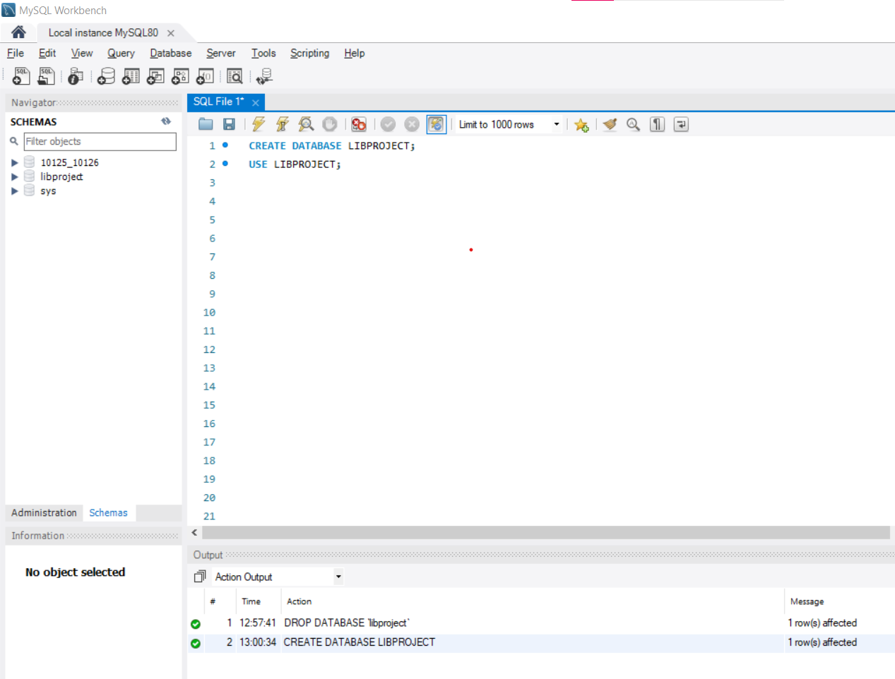



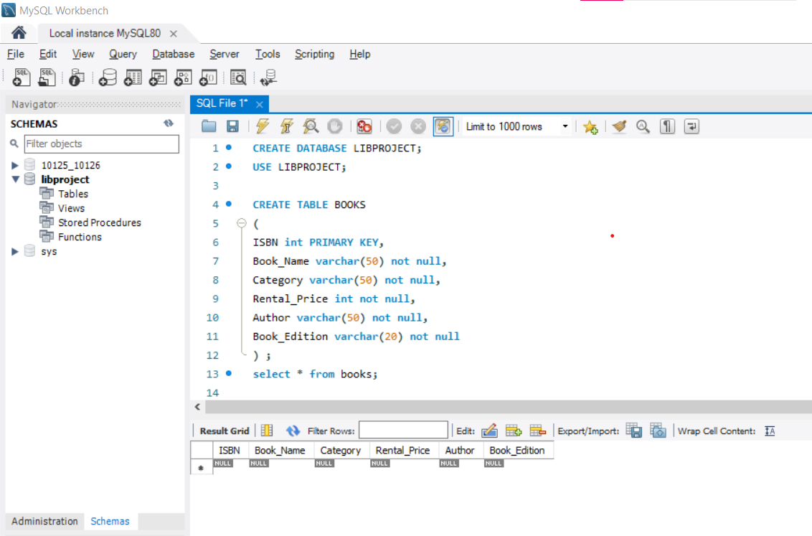



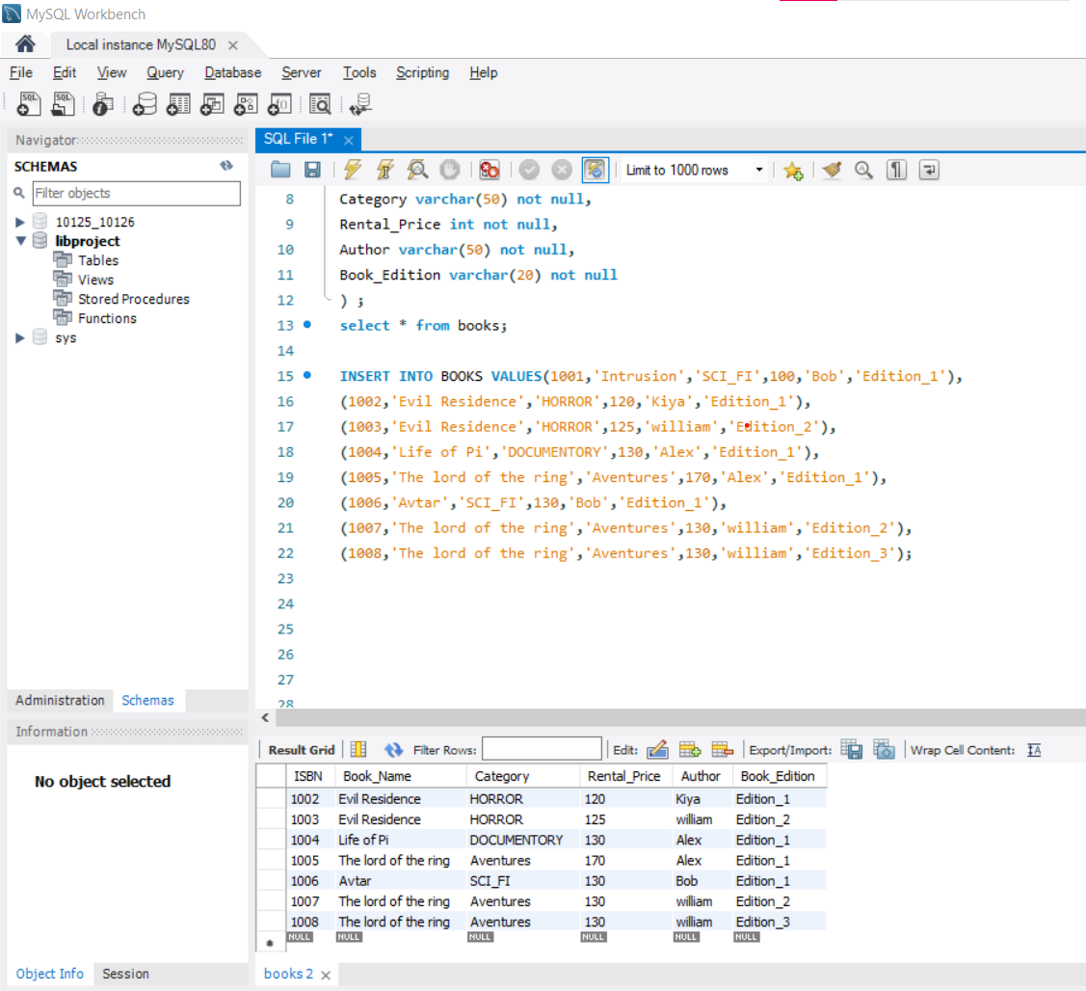

  
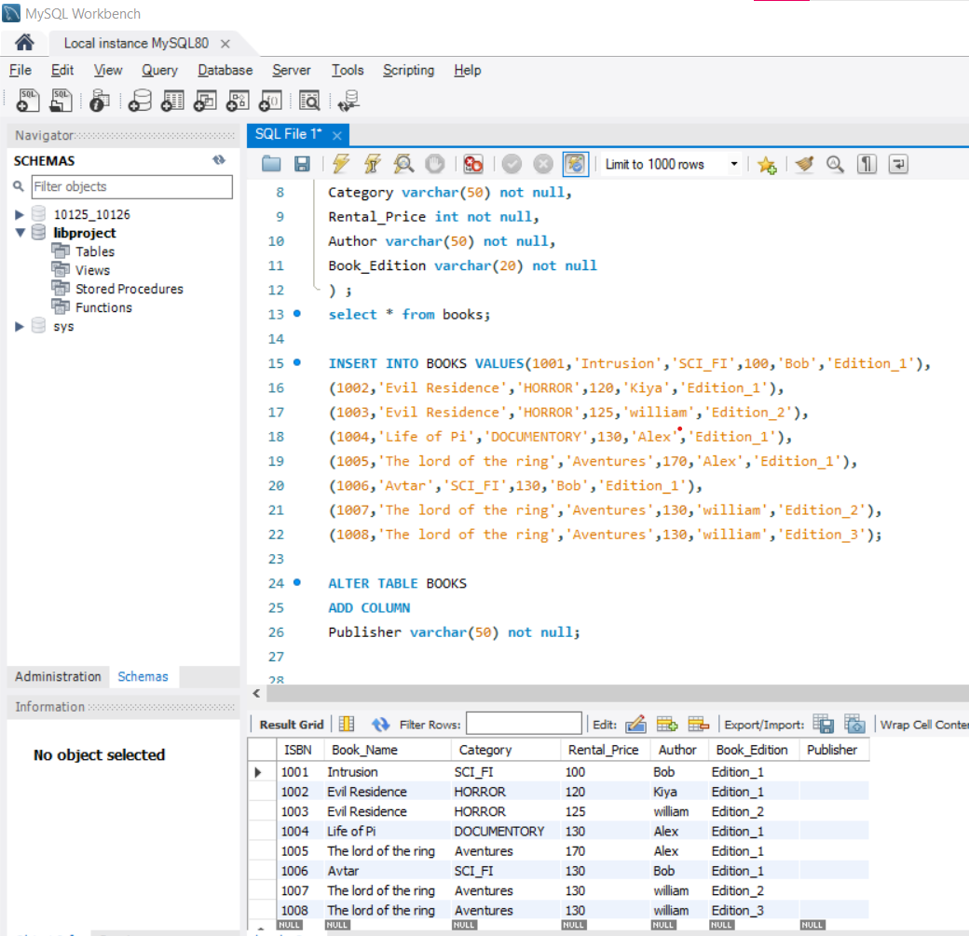

**# UPDATE BOOKS**

UPDATE BOOKS

SET publisher =**'john'**

WHERE ISBN=**1001**;

UPDATE BOOKS

SET publisher =**'elena'**

WHERE ISBN=**1002**;

UPDATE BOOKS

SET publisher =**'stefen'**

WHERE ISBN=**1003**;

UPDATE BOOKS

SET publisher =**'demon'**

WHERE ISBN=**1004**;

UPDATE BOOKS

SET publisher =**'elena'**

WHERE ISBN=**1005**;

UPDATE BOOKS

SET publisher =**'demon'**

WHERE ISBN=**1006**;

UPDATE BOOKS

SET publisher =**'demon'**

WHERE ISBN=**1007**;

UPDATE BOOKS

SET publisher =**'john'**

WHERE ISBN=**1008**;

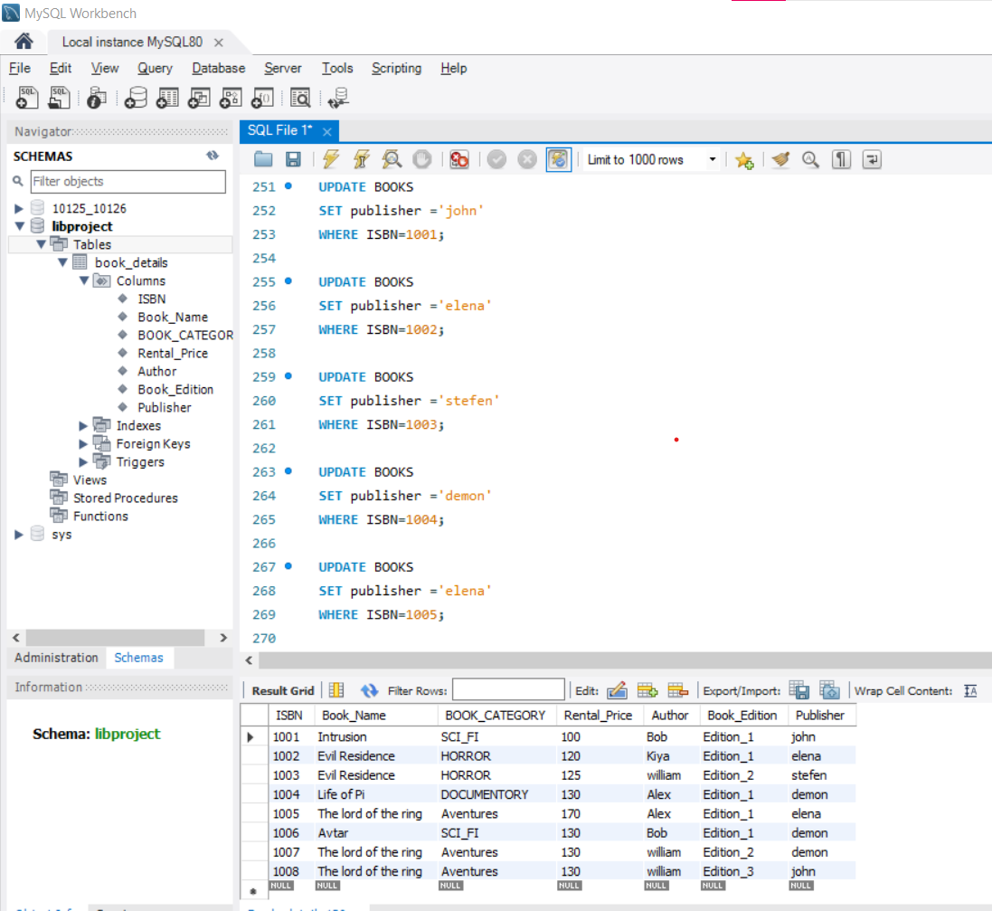

**# RENAME TABLE**

**RENAME** TABLE books to **Book_details**;

**select * from Book_details;**

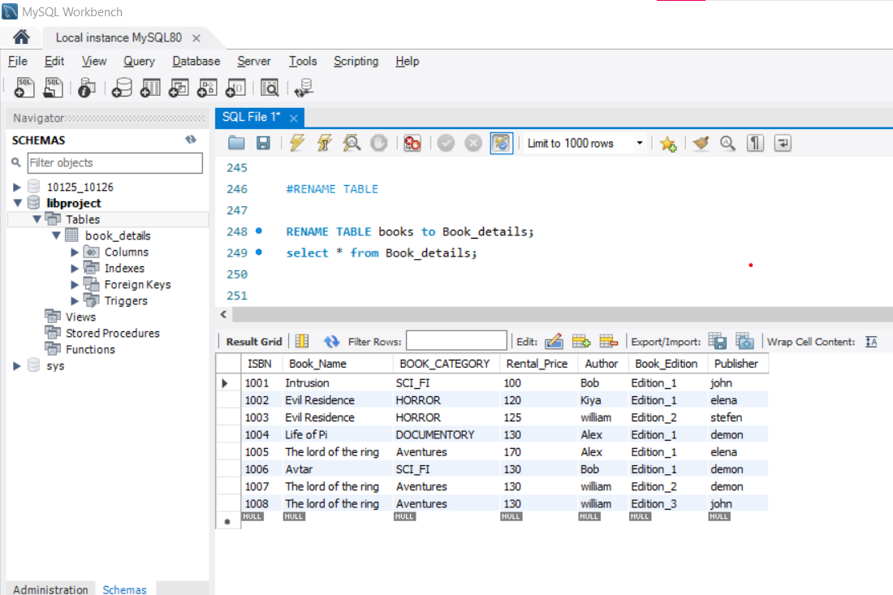

**# RENAME COLUMN NAME**

**ALTER** TABLE Book_details

**CHANGE COLUMN**

CATEGORY **BOOK_CATEGORY** varchar(20);

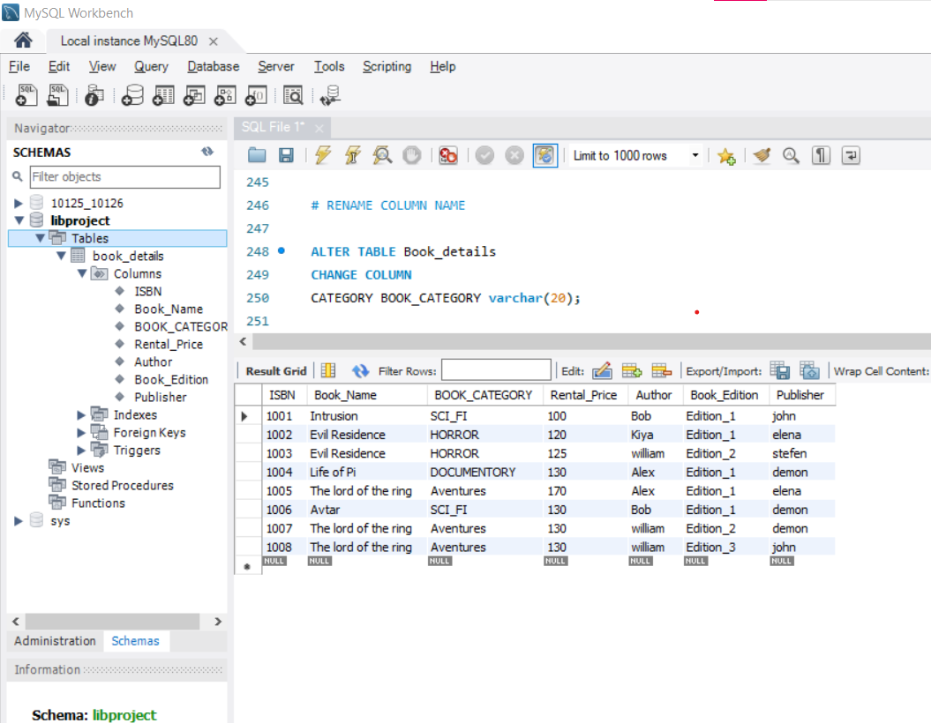

**# DESCRIBE BOOK_DETAILS**

**DESC** Book_details;

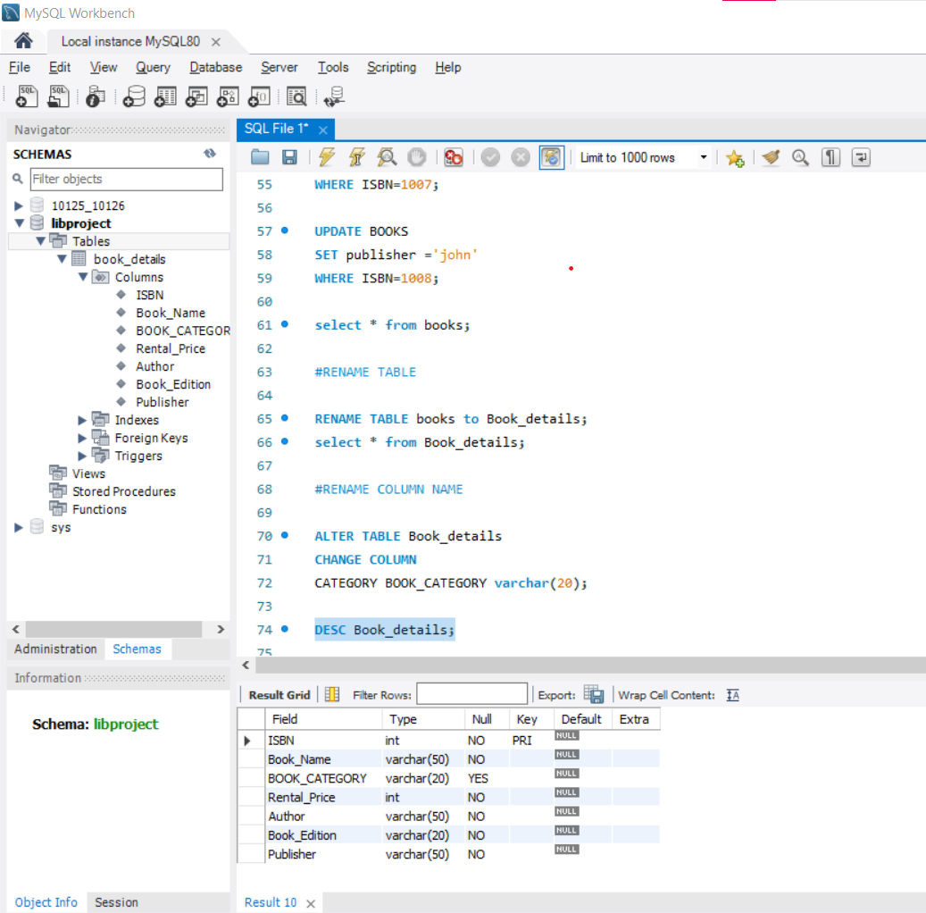

**# ADD ROW IN THE TABLE**

INSERT INTO Book_details VALUES(1009,'HAUNTEDHOUSE','HORROR',150,'ALICE','Edition_1','Caroline');

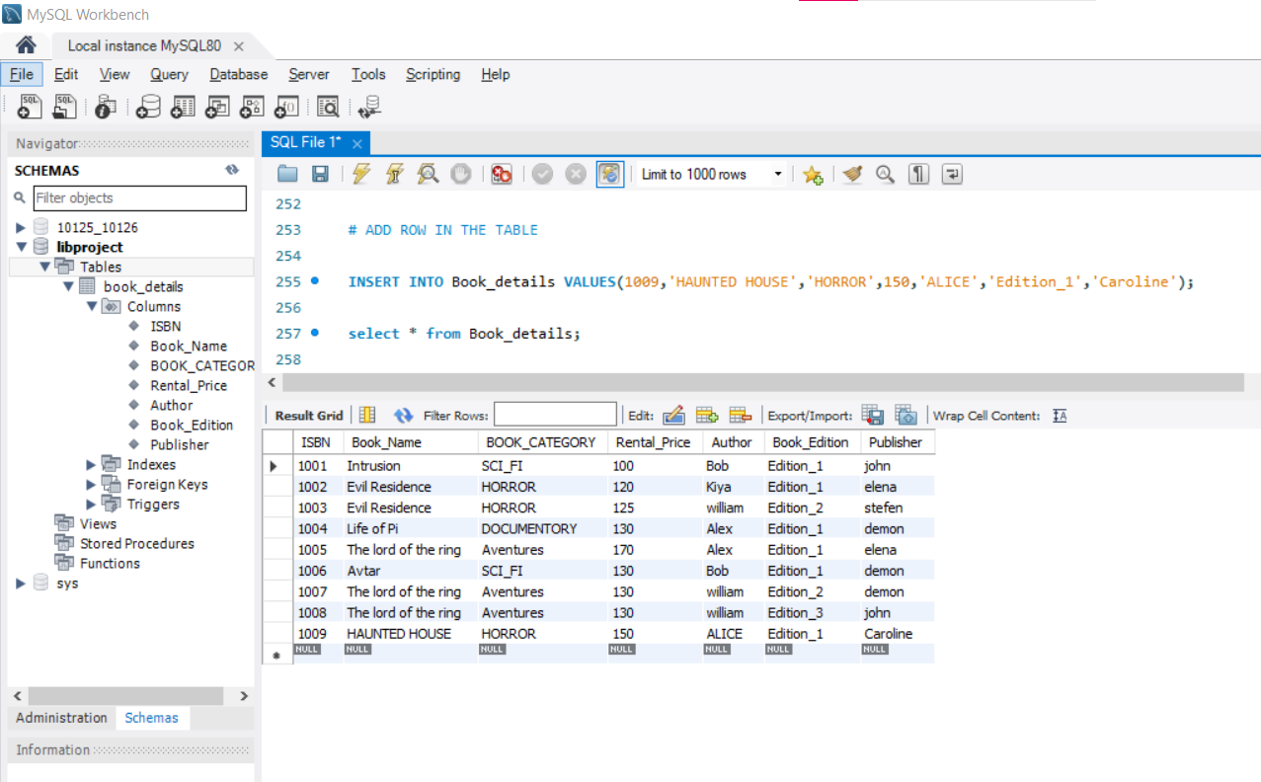

**# MODIFY ROW IN THE TABLE**

**UPDATE** Book_details

SET Book_Name= 'THE NUN'

WHERE ISBN=1009;

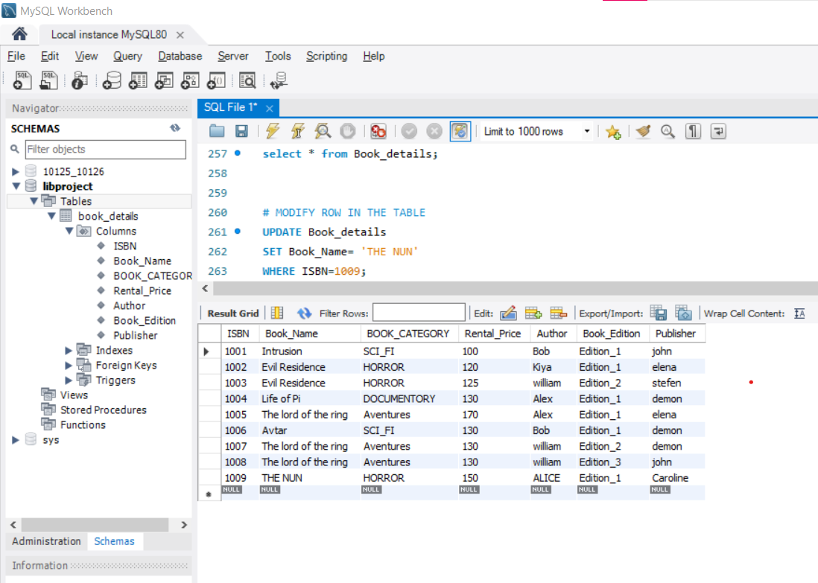

**# DELETE ROW from THE TABLE**

**DELETE** FROM Book_details

WHERE ISBN=1009;

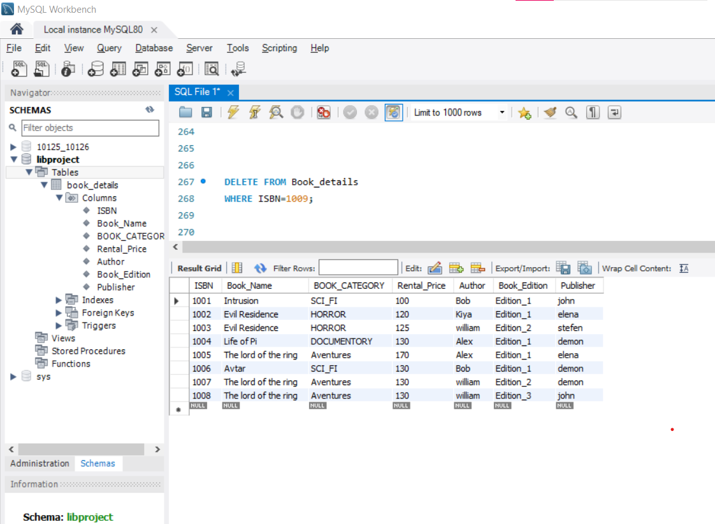

**# OPERATORS**

**1. Arithmetic Operators**

SELECT Book_Name, Rental_Price, (Rental_Price*5/100) '30% OFF', (Rental_Price*5/100)-Rental_Price 'Final Rental_Price'FROM Book_details;

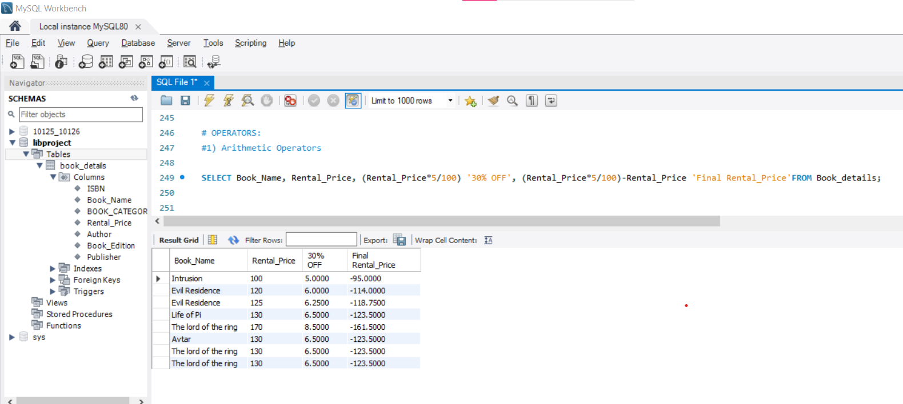

**2. Relational Operators (<,>,<=,>=,!,!=)**

SELECT * FROM Book_details

WHERE Rental_Price <130;

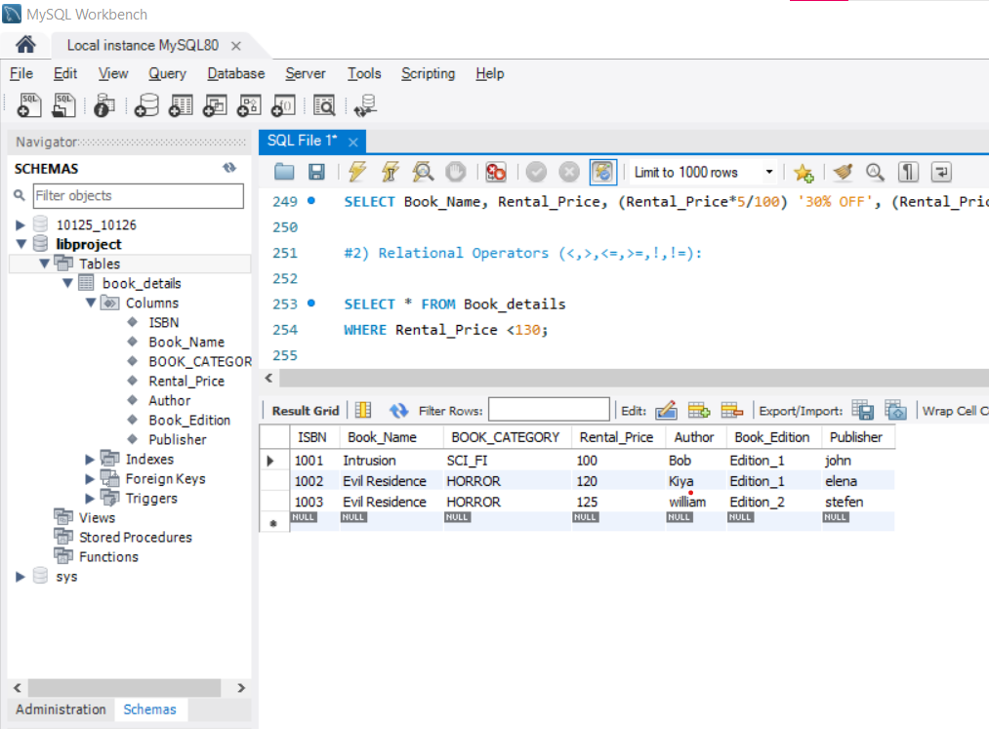

SELECT * FROM Book_details

WHERE Author **!**='BOB';

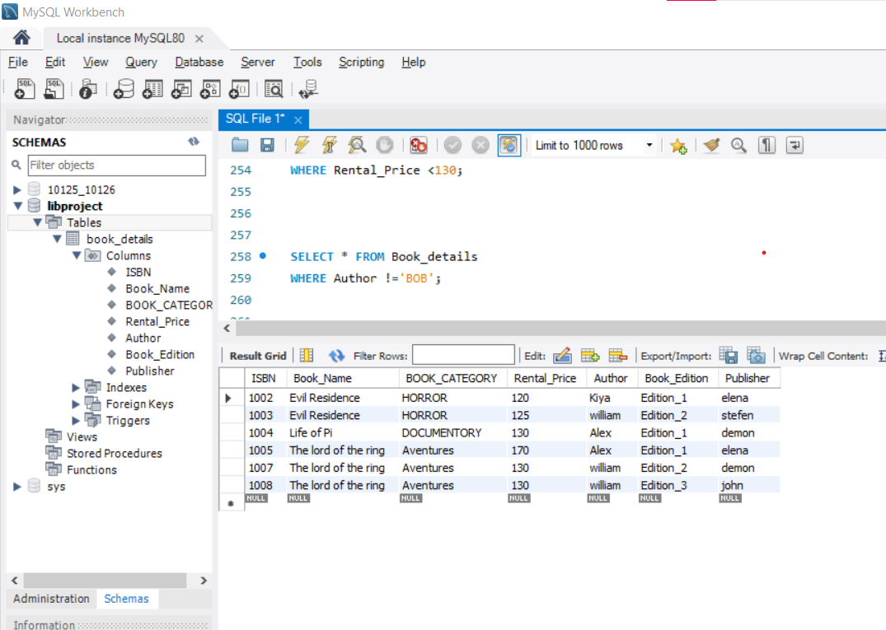

**# Between And Operator (Range)**

SELECT * FROM Book_details

WHERE Rental_Price **BETWEEN** 100 **AND** 120

ORDER BY Rental_Price DESC;

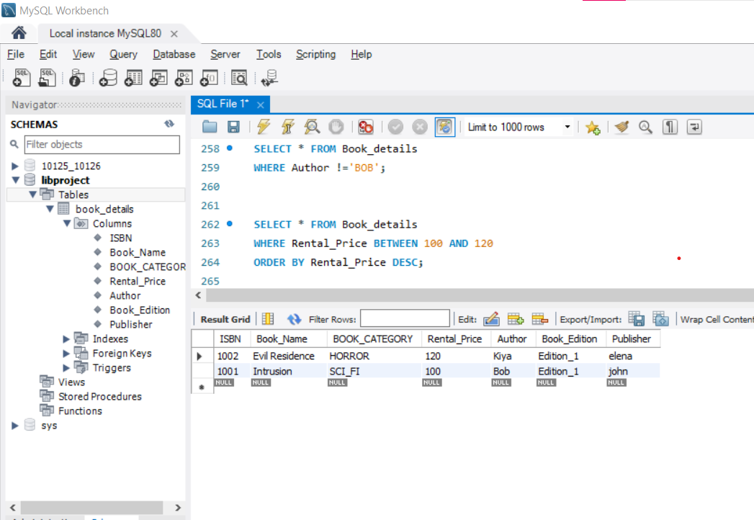

**# IN Operator>> (Collection)**

SELECT * FROM Book_details

WHERE AUTHOR **IN** ('BOB','WILLIAM');

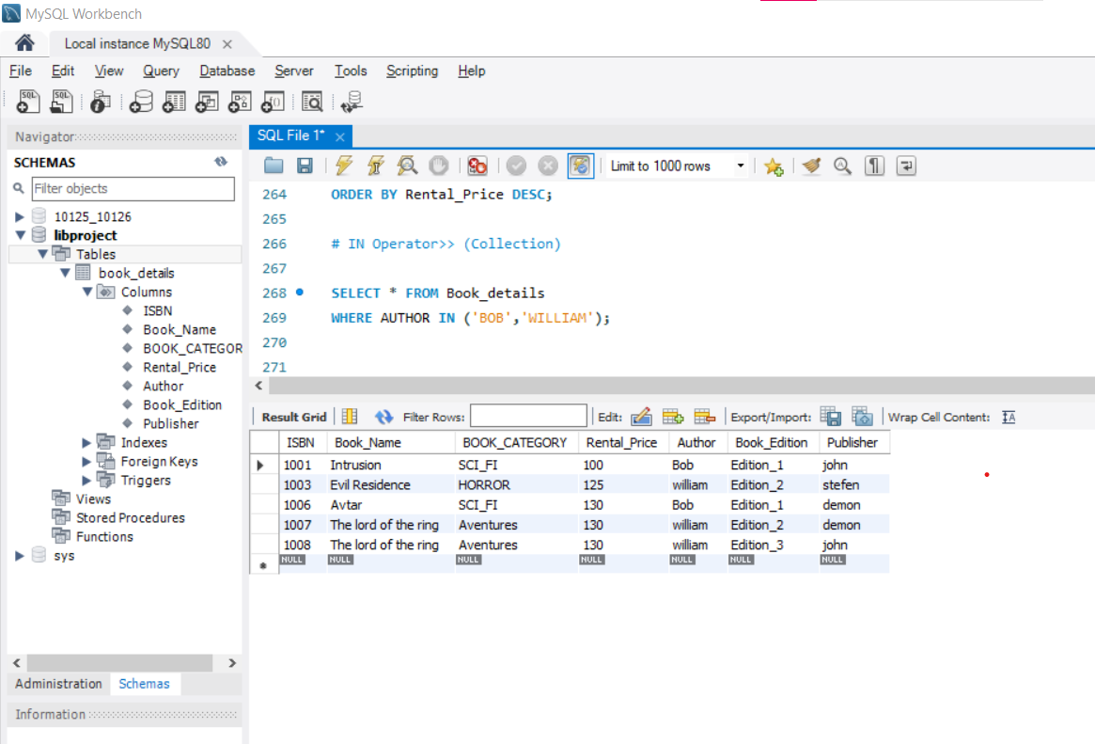

SELECT * FROM Book_details

WHERE AUTHOR **NOT IN** ('BOB','WILLIAM');

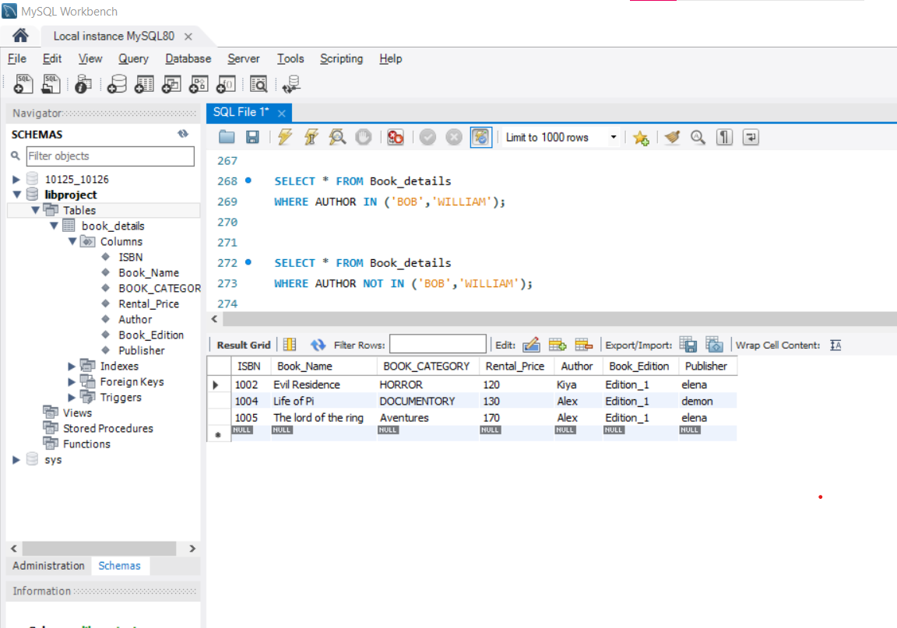

**# LIKE Operator>> WildCard Operators**

1. **'%' : length of letters is not fix**

SELECT * FROM Book_details

WHERE Book_Name LIKE '%g';

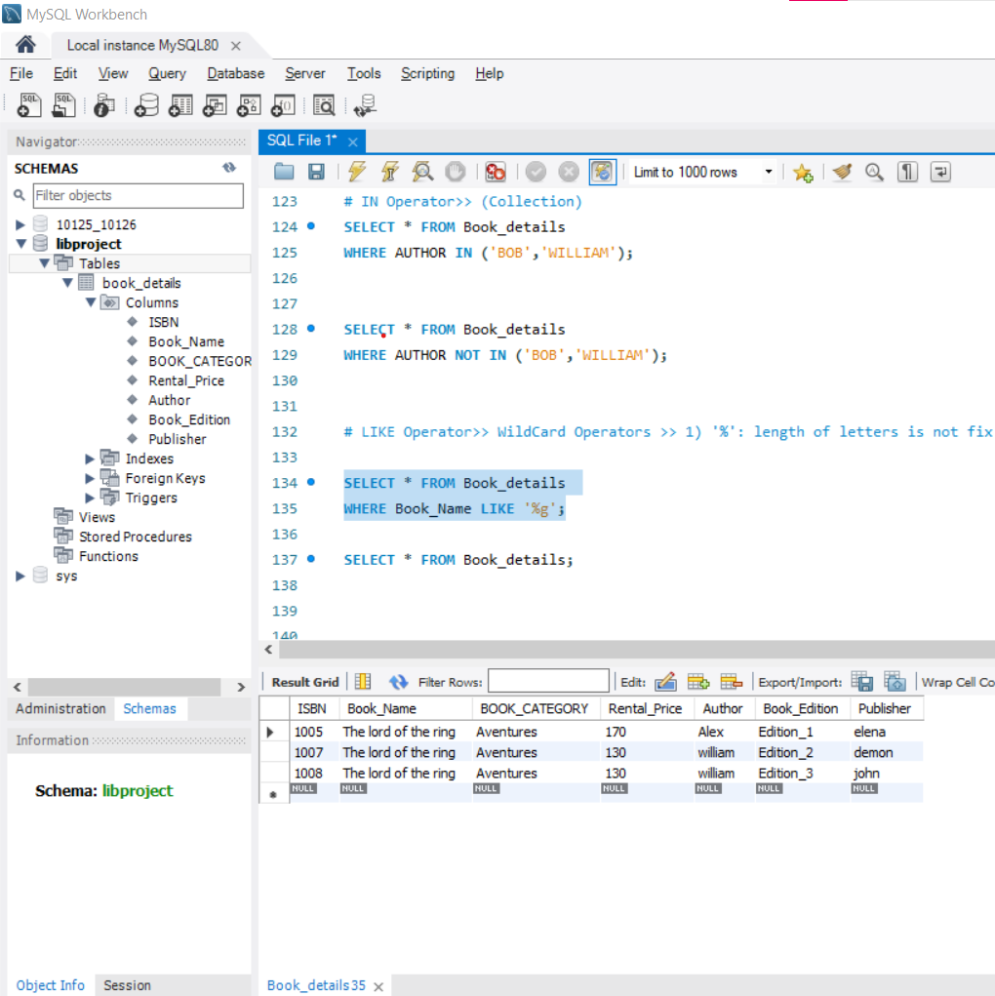

SELECT * FROM Book_details

WHERE Book_Name LIKE '**%v%';**

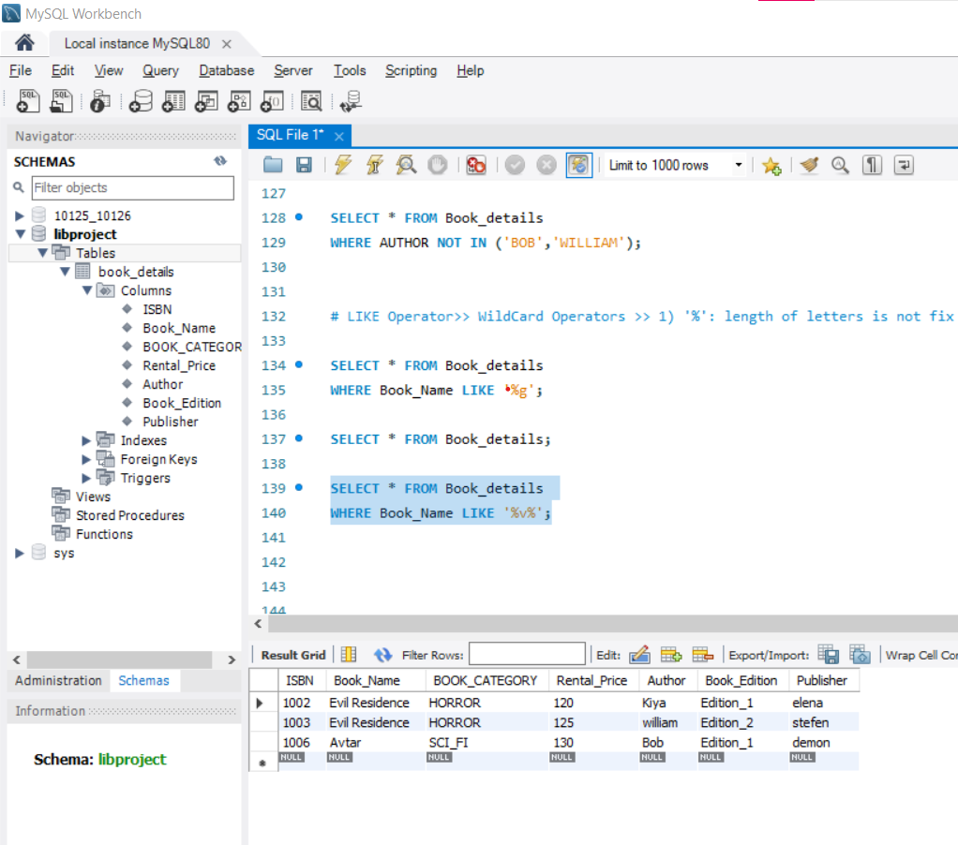

**#2) '_' : length of letters is not fix**

SELECT * FROM Book_details

WHERE Book_Name LIKE '____r';

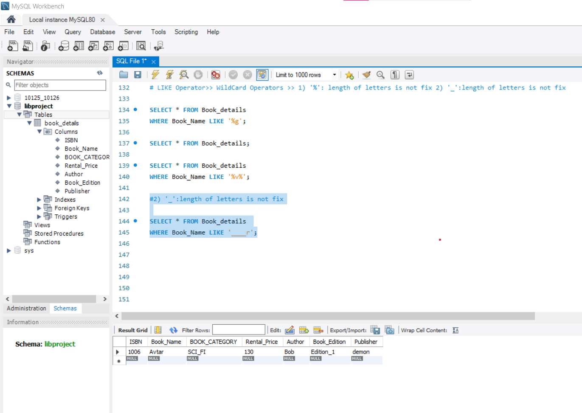

**# Logical Operators (AND, OR, NOT)**

SELECT * FROM Book_details

WHERE Rental_Price>=100 **AND** BOOK_CATEGORY='SCI_FI';

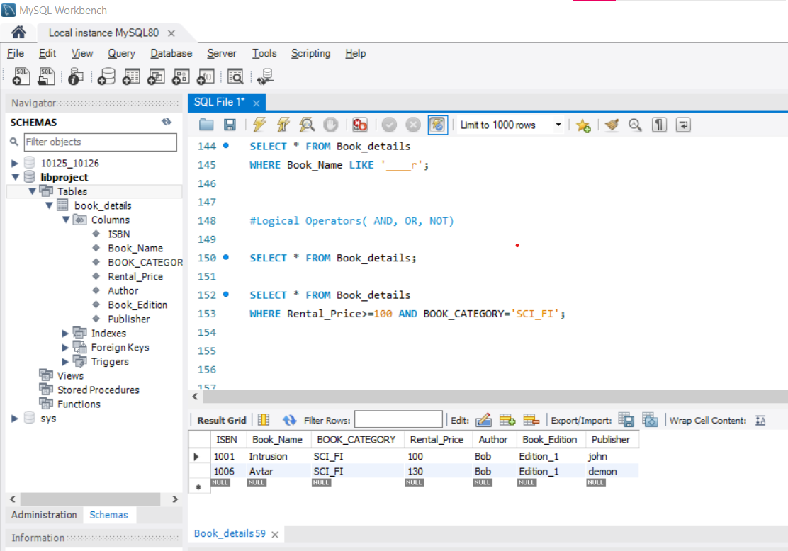

SELECT * FROM Book_details

WHERE (Rental_Price>=130 **AND** BOOK_CATEGORY='SCI_FI') **OR** BOOK_CATEGORY='HORROR';

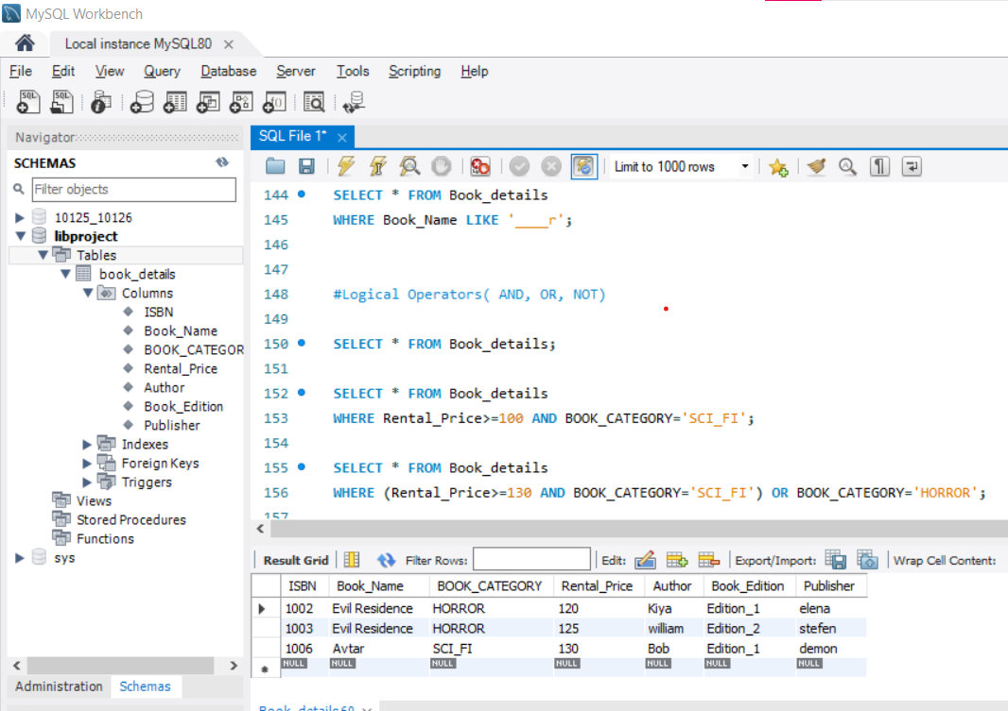

SELECT * FROM Book_details

WHERE **NOT** Book_Edition ='Edition_1';

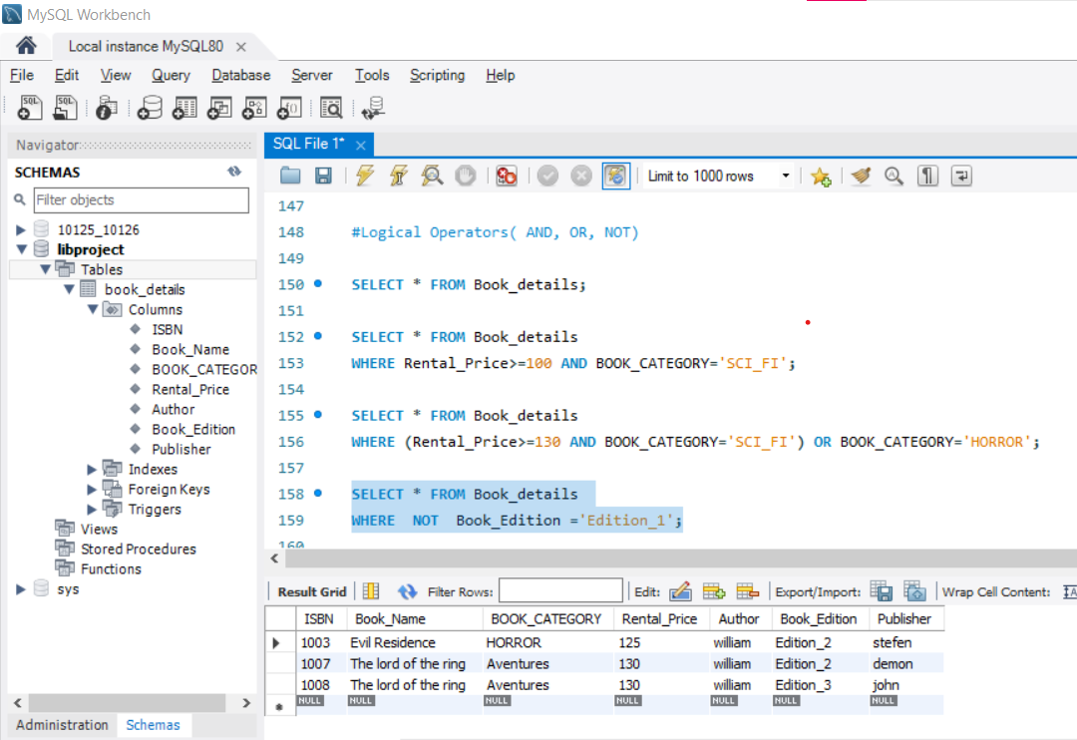

SELECT **DISTINCT** BOOK_CATEGORY FROM Book_details ;

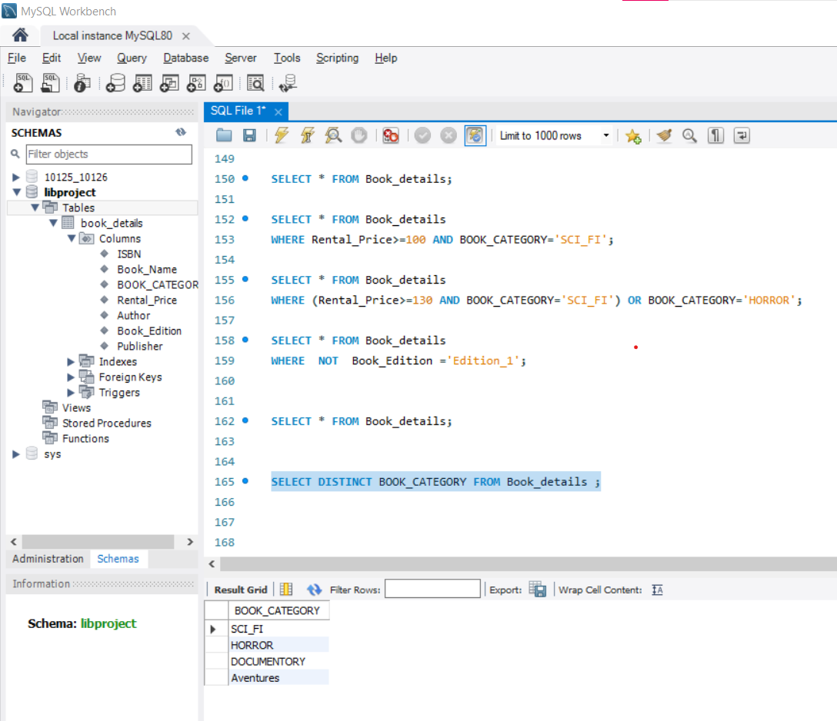

**# AGGREGATE FUNCTION**

SELECT BOOK_CATEGORY, **MAX**(Rental_Price) FROM Book_details

**GROUP BY** BOOK_CATEGORY

ORDER BY MAX(Rental_Price) DESC;

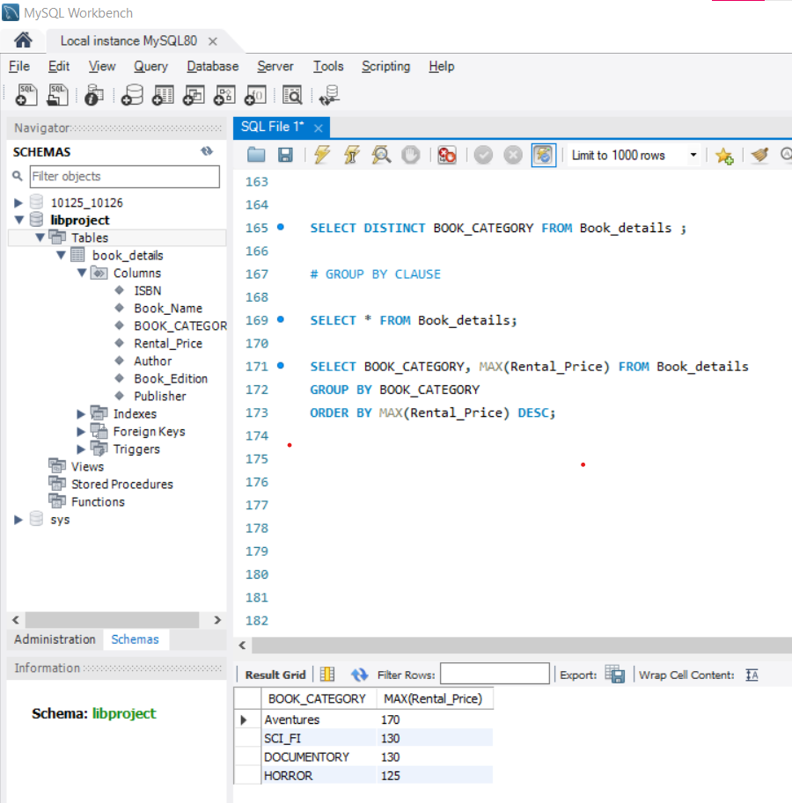

SELECT Book_Edition, **SUM**(Rental_Price) FROM Book_details

**GROUP BY** Book_Edition

ORDER BY SUM(Rental_Price) DESC;

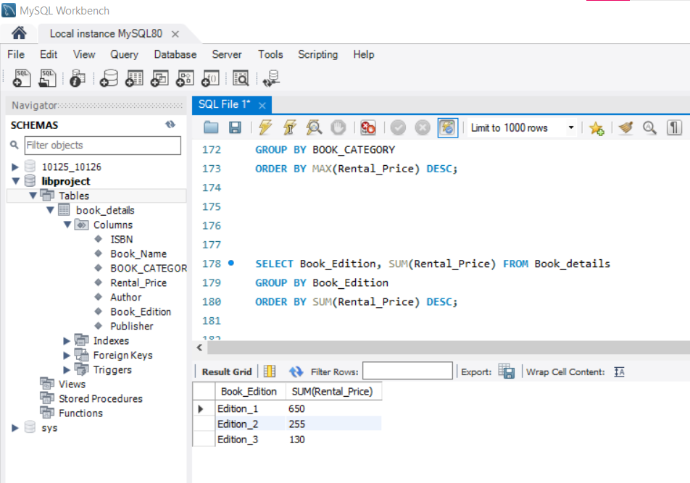

SELECT Book_Edition, **AVG**(Rental_Price) FROM Book_details

**GROUP BY** Book_Edition

**HAVING** AVG(Rental_Price)>=130

**ORDER BY** AVG(Rental_Price) DESC;

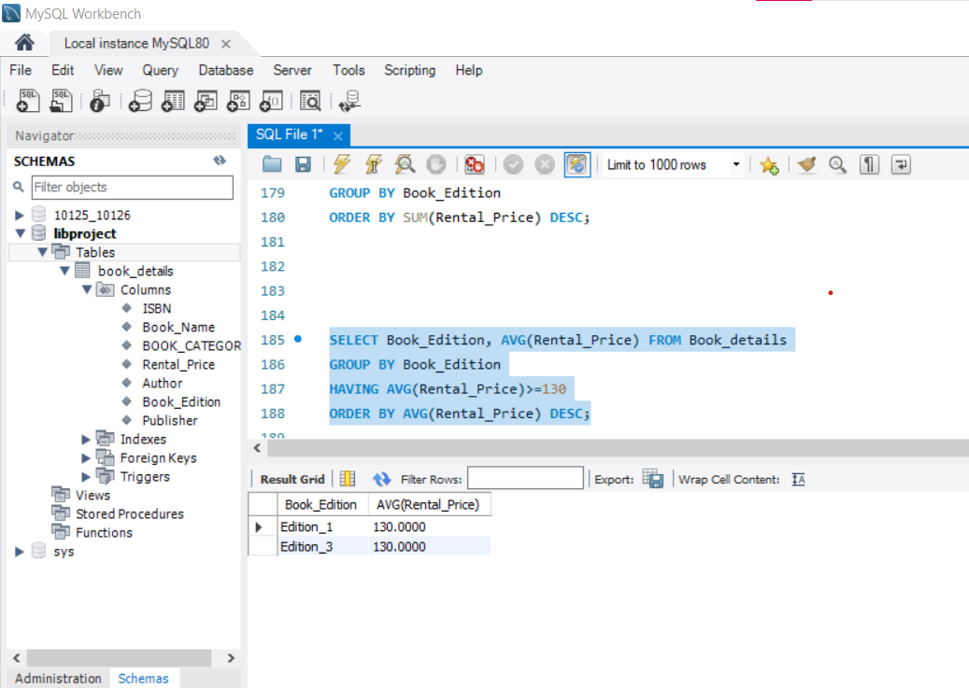

SELECT Publisher, **COUNT**(BOOK_CATEGORY) FROM Book_details

**GROUP BY** Publisher

**HAVING** COUNT(BOOK_CATEGORY)>=1

**ORDER BY** COUNT(BOOK_CATEGORY) DESC;

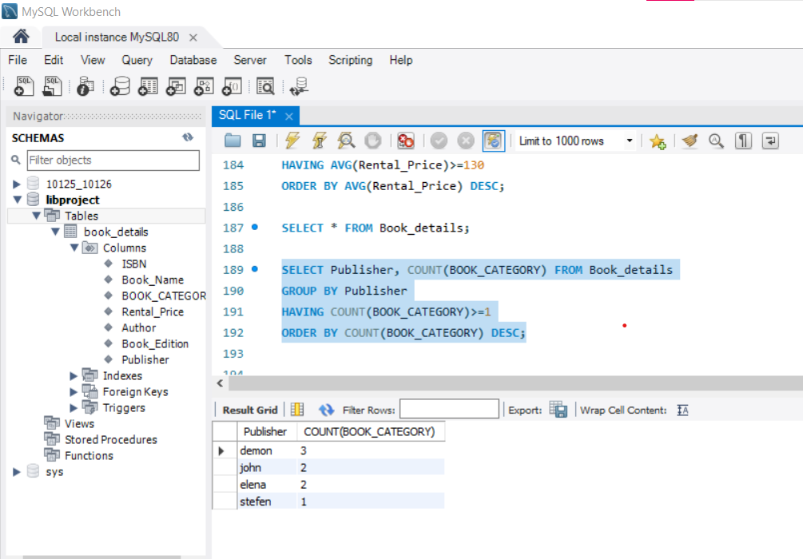

SELECT Publisher,BOOK_CATEGORY, Book_Edition, **MIN**(Rental_Price) FROM Book_details

**GROUP BY** Publisher, BOOK_CATEGORY, Book_Edition

**HAVING** MIN(Rental_Price)<130

**ORDER BY** MIN(Rental_Price) DESC;

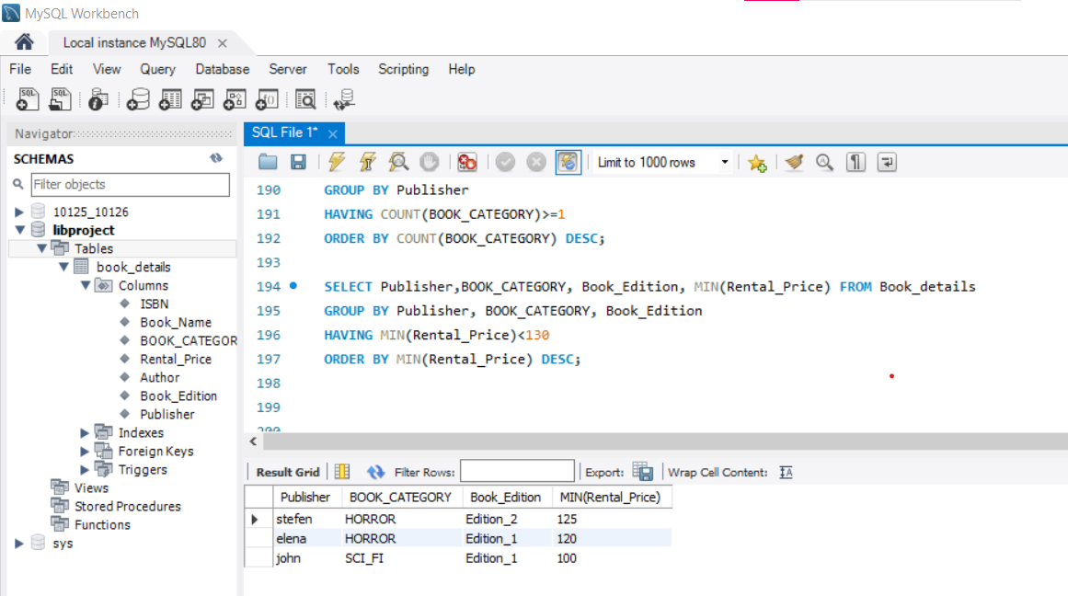

**# SUBQUERY: Query inside another query / Nested Query**

**# 1ST HIGHEST RENTAL_PRICE**

SELECT * FROM Book_details

WHERE Rental_Price=

(

SELECT MAX(Rental_Price) FROM Book_details

WHERE Rental_Price=

(

SELECT MAX(Rental_Price) FROM Book_details

));

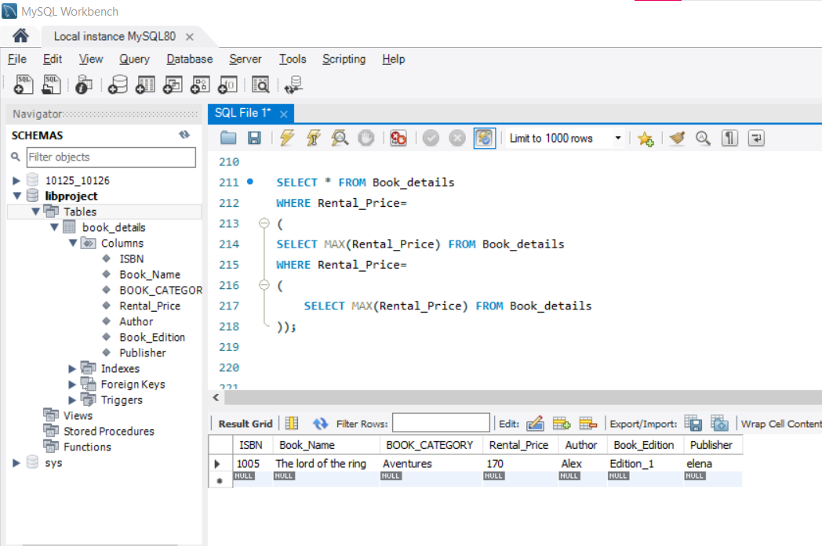

**# 2ND HIGHEST Rental_Price**

SELECT * FROM Book_details

WHERE Rental_Price=

(

SELECT DISTINCT MAX(Rental_Price) FROM Book_details

WHERE Rental_Price<

(

SELECT MAX(Rental_Price) FROM Book_details

));

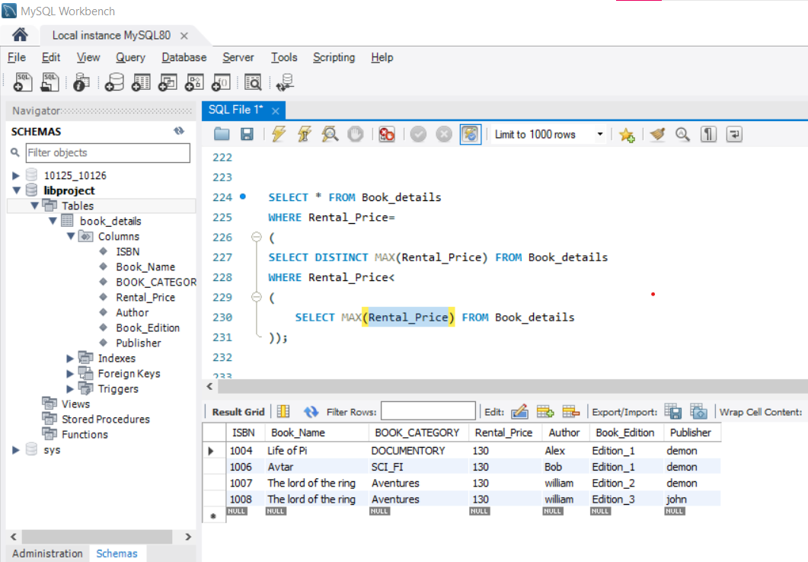

**# 6TH HIGHEST RENTAL_PRICE**

SELECT * FROM Book_details;

SELECT * FROM Book_details

ORDER BY Rental_Price DESC

LIMIT 1

OFFSET 5;

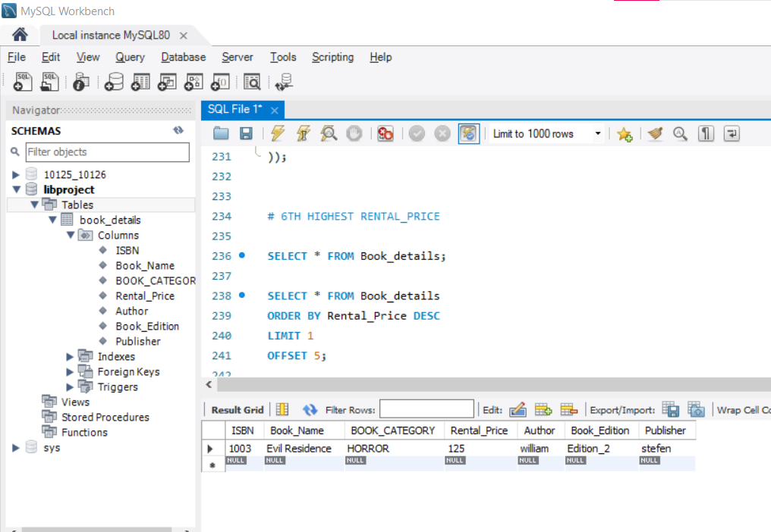

**# SINGLE ROW FUNCTIONS**

**1. 1 UPPERCASE- SPECIFIC CELL**

SELECT UPPER(Publisher) FROM Book_details

WHERE ISBN=1001;

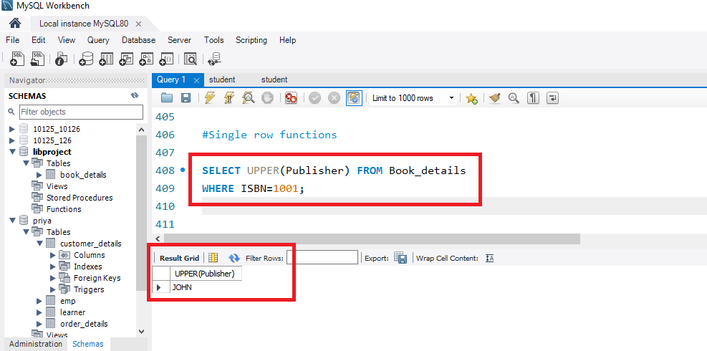

**1. 2 UPPERCASE- SPECIFIC COLUMN**

SELECT UPPER(Publisher) FROM Book_details;

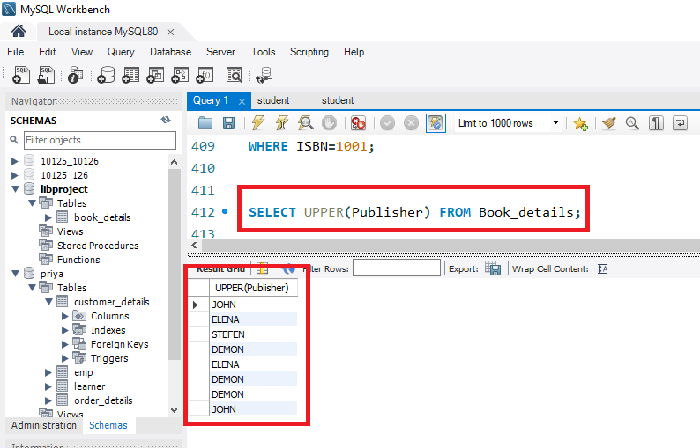

**2. LOWERCASE**

SELECT LOWER(BOOK_CATEGORY) FROM Book_details

WHERE ISBN IN (1002,1003);

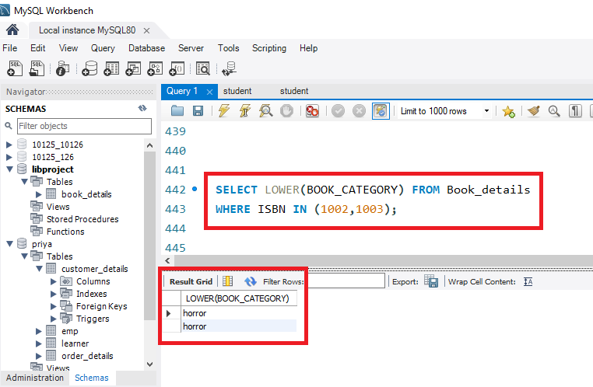

**3. CONCAT Combination of two columns**

SELECT CONCAT (ISBN,Book_Name) From Book_details;

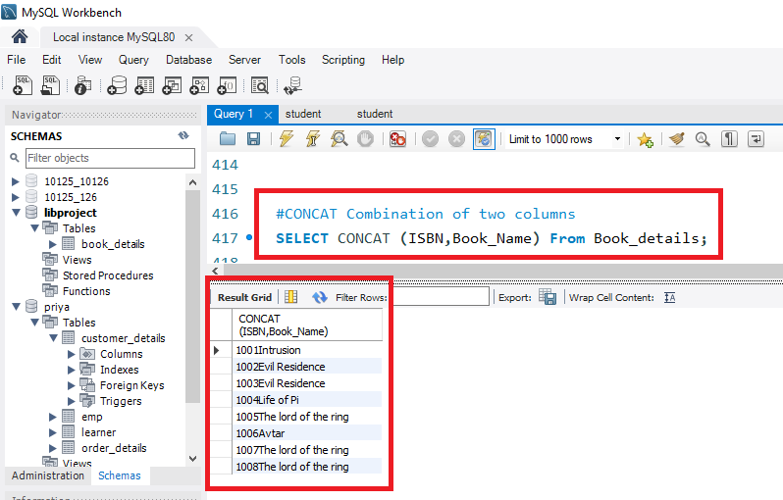

**4. REPLACE the Alphabets**

SELECT **REPLACE** ('john','j','k') FROM Book_details

WHERE ISBN=1001;

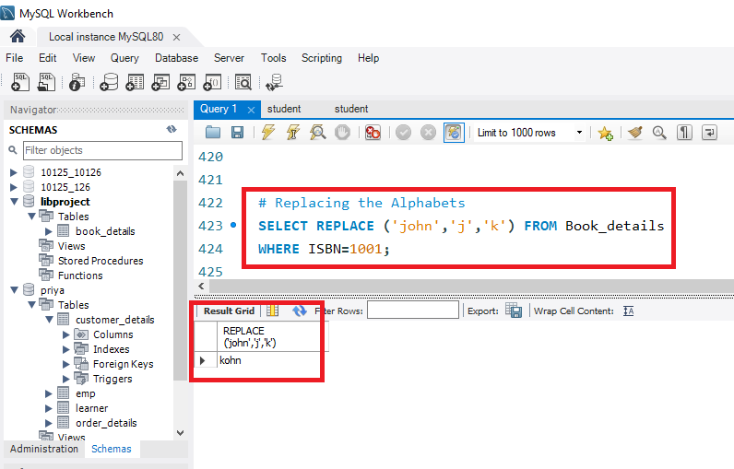

**5. Square Root**

SELECT SQRT (Rental_Price) FROM Book_details;

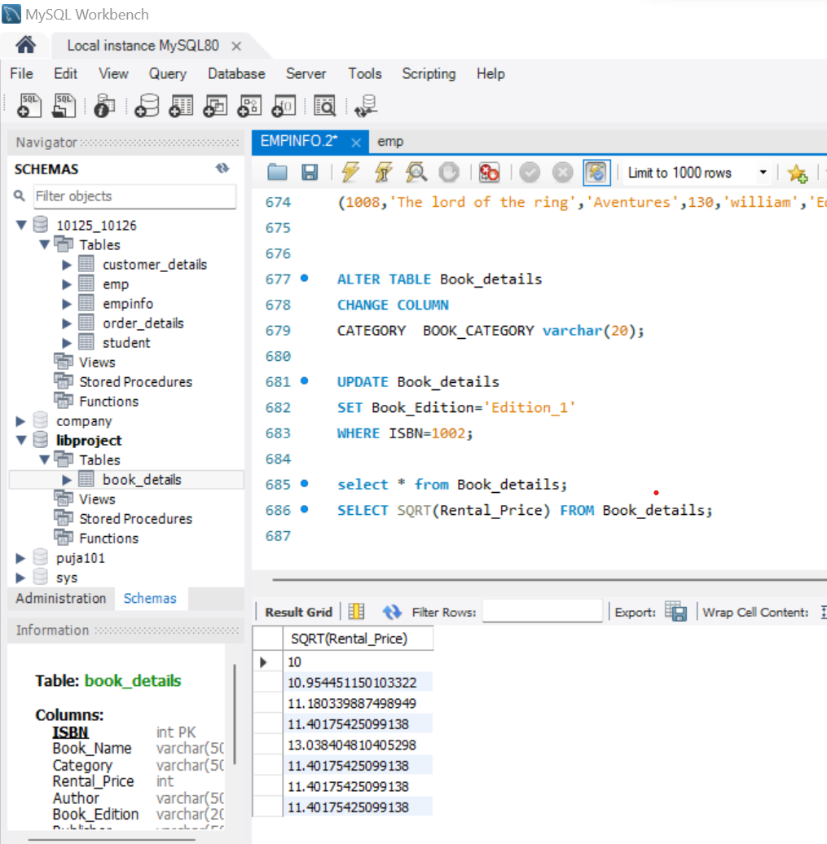

**6. Round the values**

Select Book_Name, BOOK_CATEGORY, Rental_Price, round(120.5) as 'Round_price_rental' FROM Book_Details

WHERE ISBN=1002;

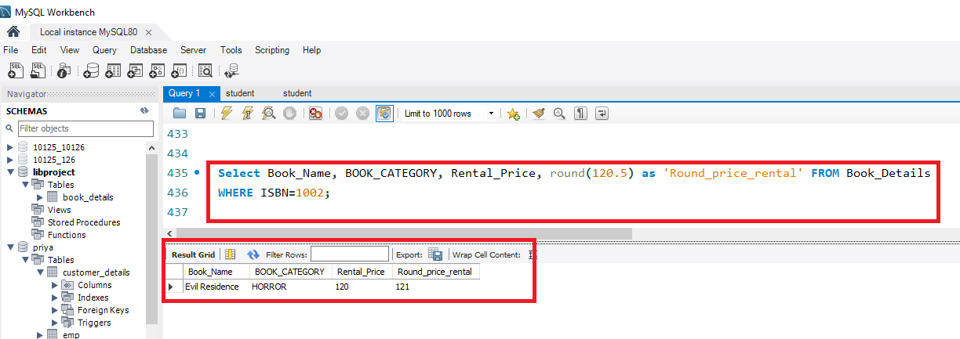

**7. Modulus**

Select MOD(Rental_Price, 2) FROM Book_Details;

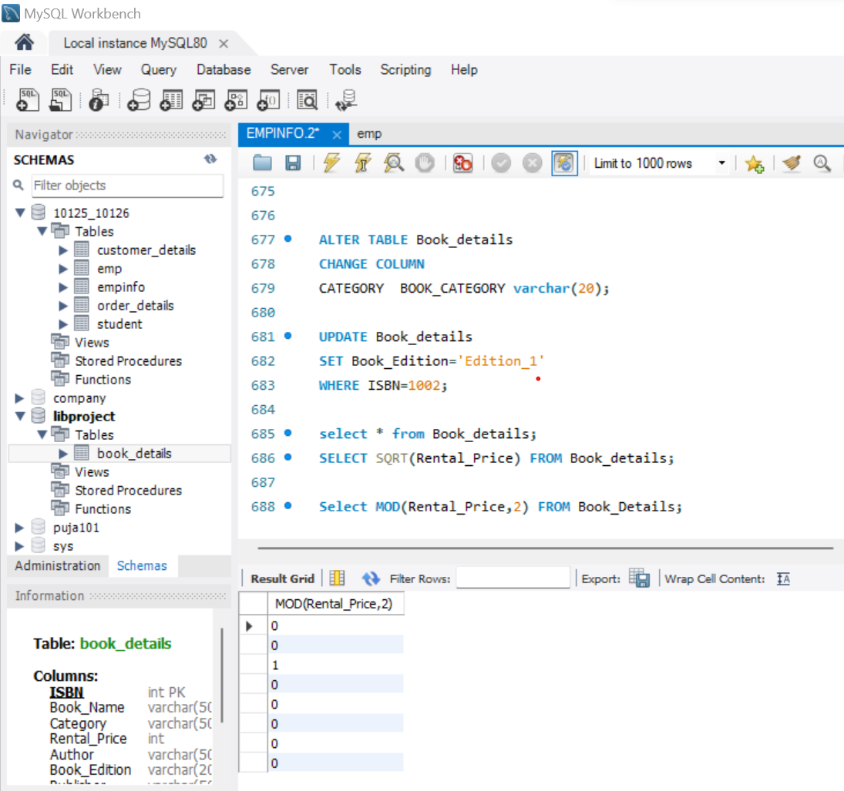

**8. Substring**

SELECT ISBN, Rental_Price, **SUBSTR**(Book_Name,1,3) FROM Book_Details

WHERE ISBN IN (1001,1002,1004,1008);

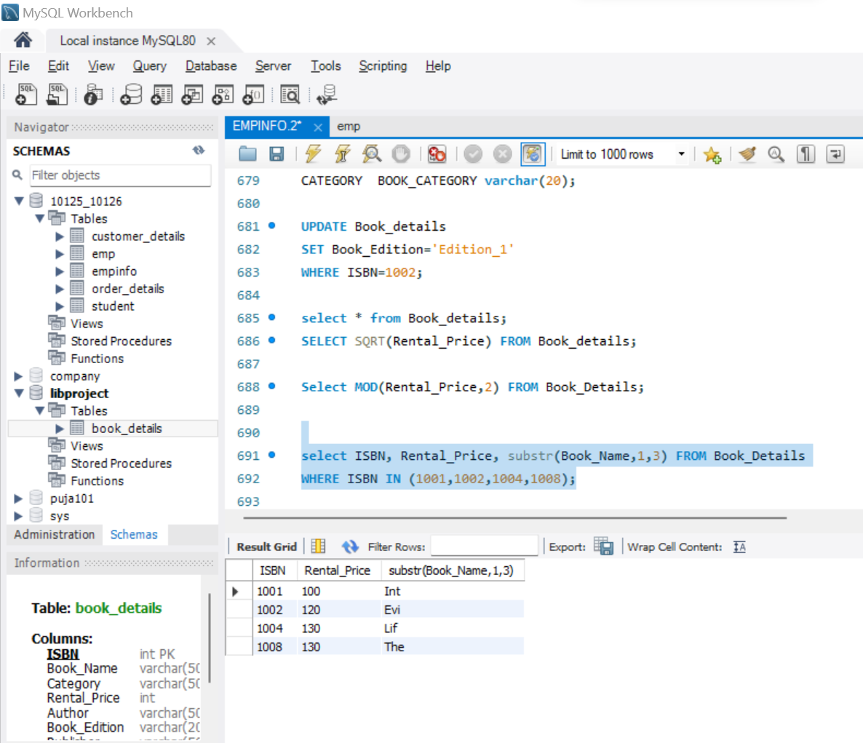

SELECT SUBSTR(Book_Name,1,3) FROM Book_Details;

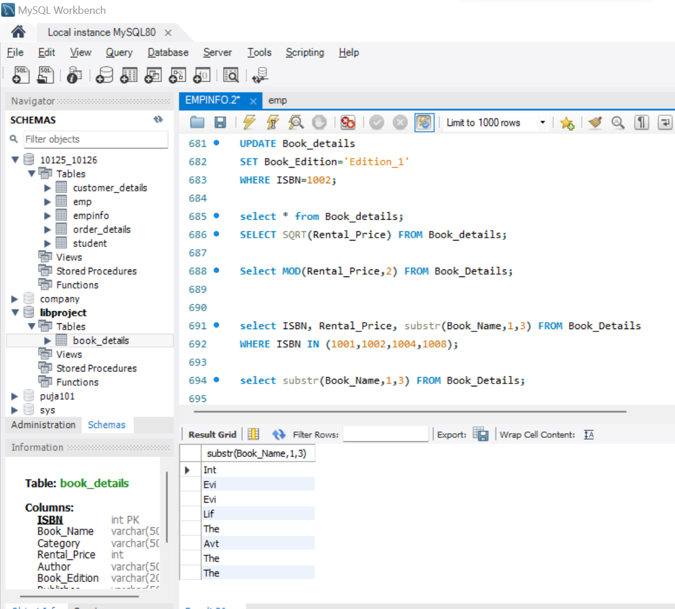

**# JOIN**

**CREATE TABLE BOOK_DETAILS**

(

ISBN int PRIMARY KEY,

Book_Name varchar(50) not null,

Category varchar(50) not null,

Rental_Price int not null,

Author varchar(50) not null,

Book_Edition varchar(20) not null

) ;

select * from book_details;

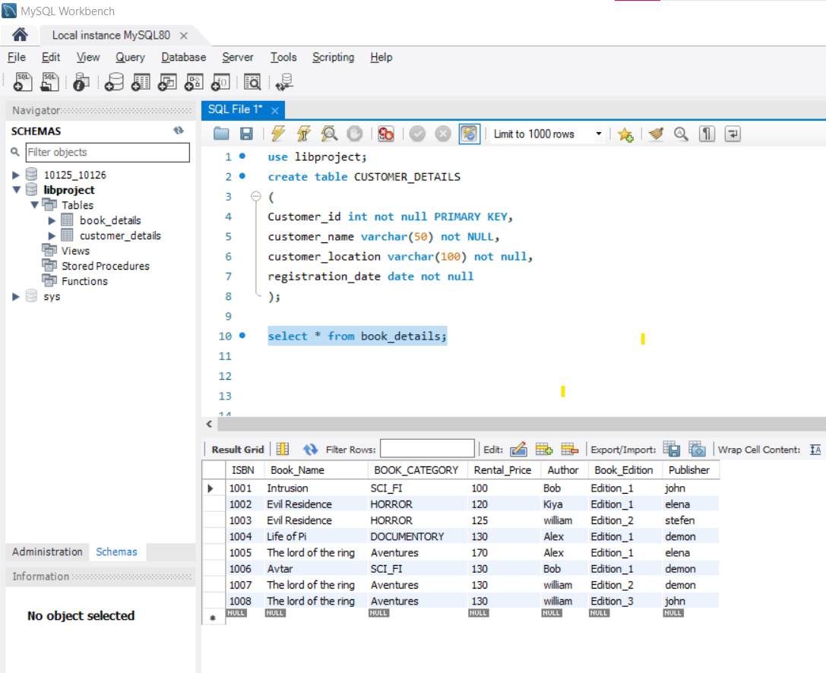

**CREATE table CUSTOMER_DETAILS**

(

Customer_id int not null PRIMARY KEY,

customer_name varchar(50) not NULL,

customer_location varchar(100) not null,

registration_date date not null

);

SELECT * from CUSTOMER_DETAILS;

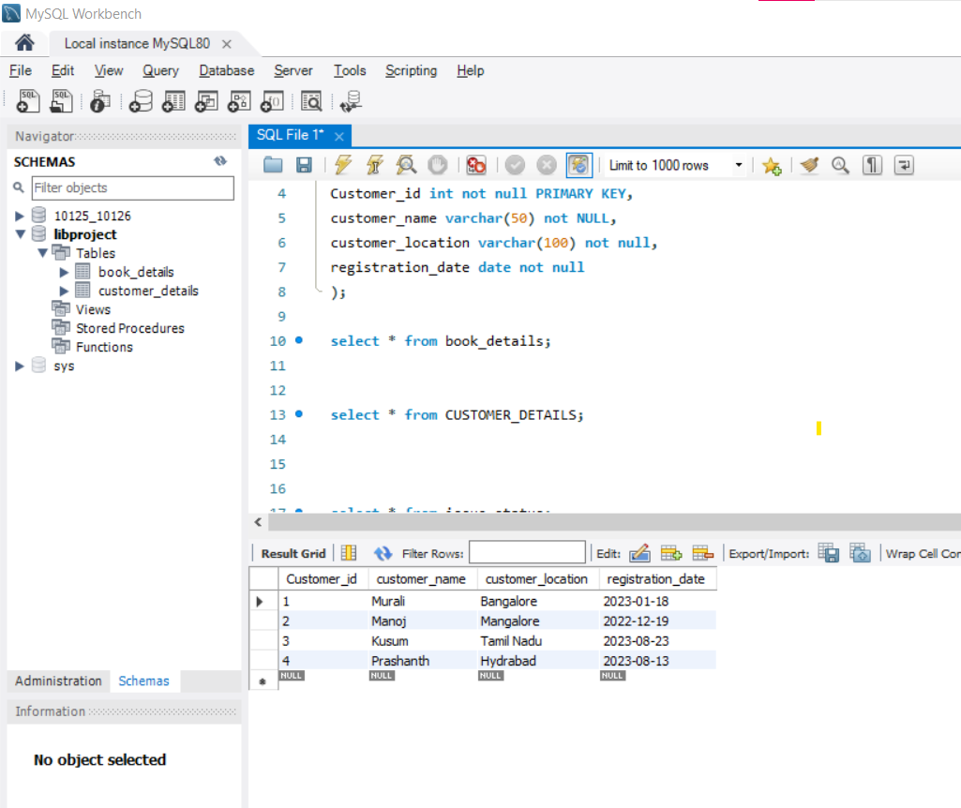

**CREATE table issue_status**

(

issue_id int primary key,

issue_customer_id int not Null,

issued_book_name varchar(50) not null,

issue_date date not null,

ISBN int,

constraint foreign key(ISBN) references Book_details(ISBN),

constraint foreign key(issue_customer_id) references CUSTOMER_DETAILS(customer_id));

SELECT * from issue_status;

INSERT INTO issue_status VALUES(101,2,'Life of Pi','2023-01-29',1004);

INSERT INTO issue_status VALUES(102,4,'Avtar','2023-02-28',1006);

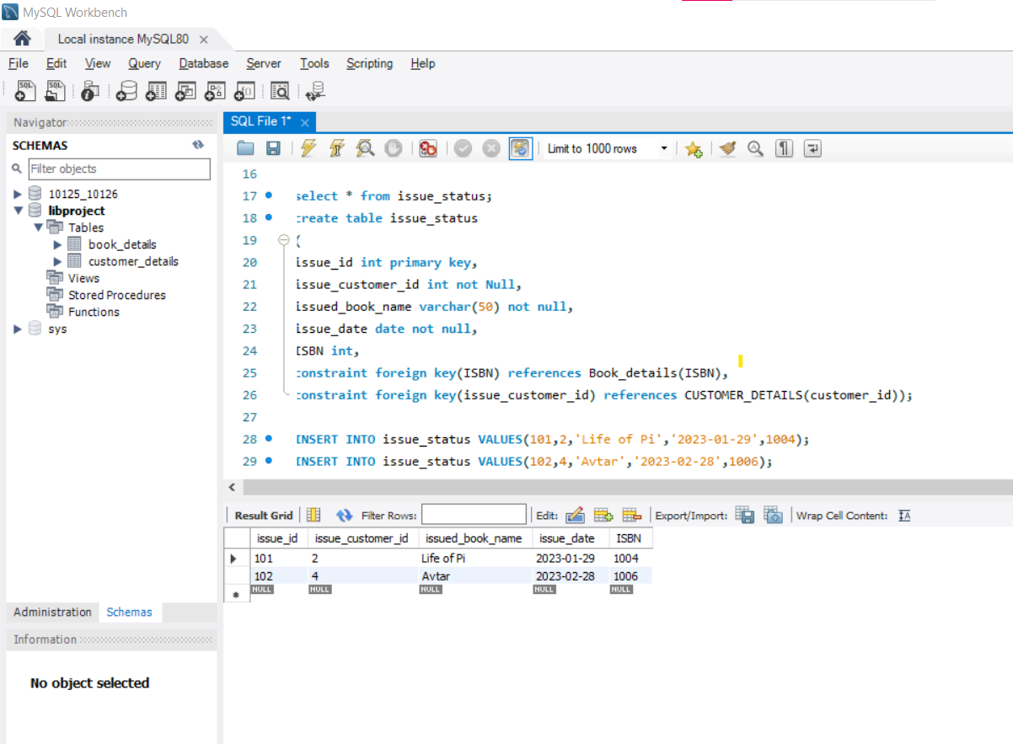

**CREATE table return_status**

(

return_id int not null primary key,

return_cust_id int not null,

returned_book_name varchar(50) not null,

return_date date not null,

isbn int not null,

constraint foreign key(isbn) references Book_details(ISBN),

constraint foreign key(return_cust_id) references issue_status(issue_customer_id)

);

INSERT INTO return_status VALUES(201,2,'Life of Pi','2023-04-29',1004);

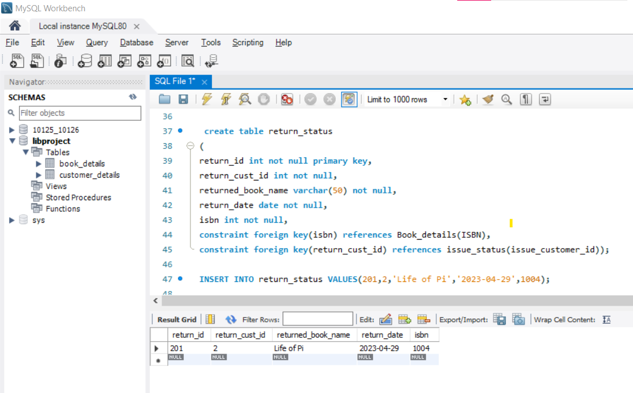

SELECT * FROM **book_details INNER JOIN return_status**

ON book_details.ISBN=return_status.ISBN;

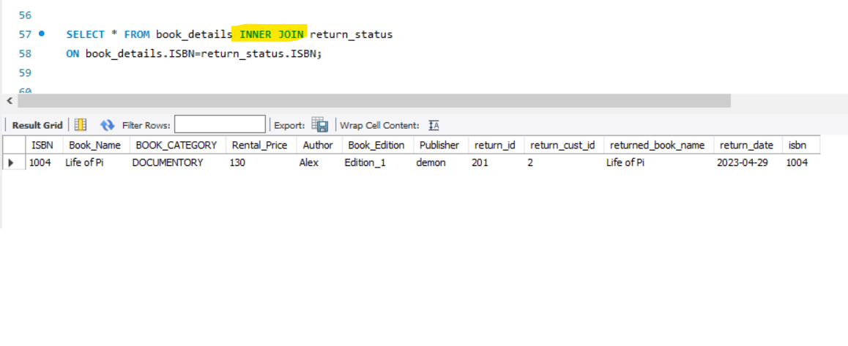

SELECT * FROM **book_details LEFT JOIN return_status**

ON book_details.ISBN=return_status.ISBN;

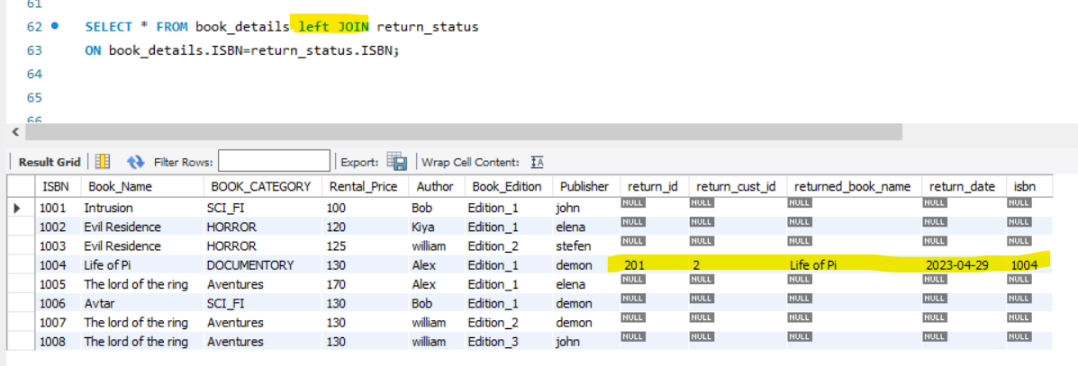

SELECT * FROM **book_details JOIN issue_status**

ON book_details.ISBN=issue_status.ISBN;

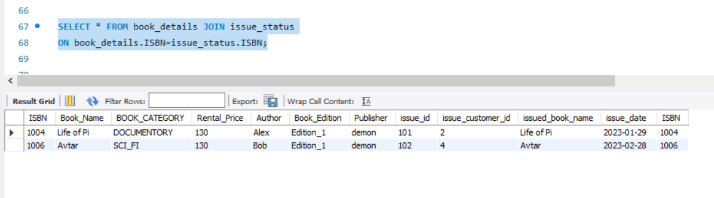

SELECT * FROM book_details LEFT JOIN issue_status

ON book_details.ISBN=issue_status.ISBN;

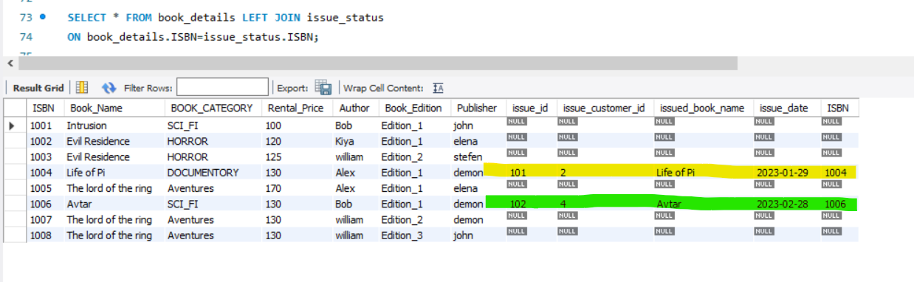

SELECT * FROM **issue_status JOIN return_status**

ON issue_status.ISBN=return_status.ISBN;

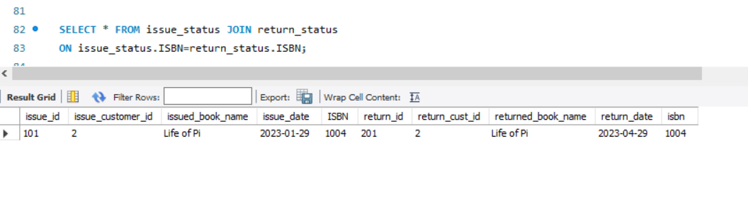

SELECT * FROM issue_status left JOIN return_status

ON issue_status.ISBN=return_status.ISBN;

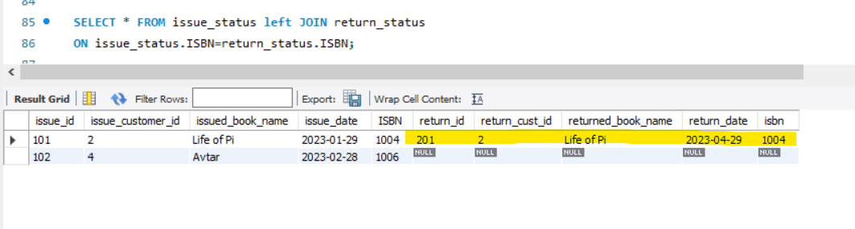

**# SELF JOIN**

SELECT a.customer_name, b.customer_location from CUSTOMER_DETAILS a , CUSTOMER_DETAILS b

WHERE b.customer_location='BANGALORE';

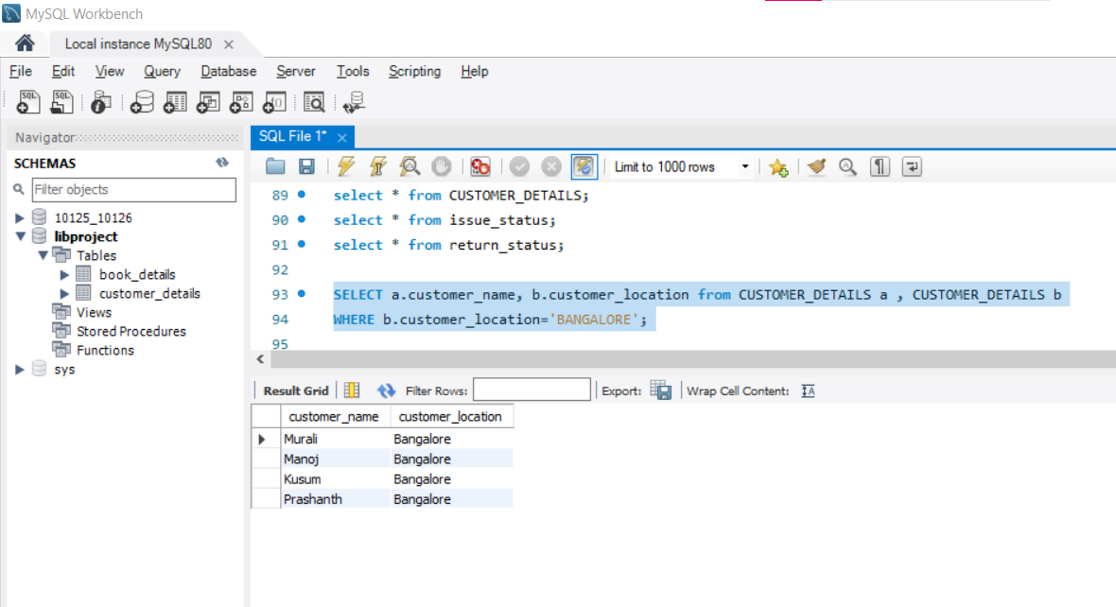

SELECT a.Book_Name, b.Book_Edition from book_details a , book_details b

WHERE b.Book_Edition='Edition_2';

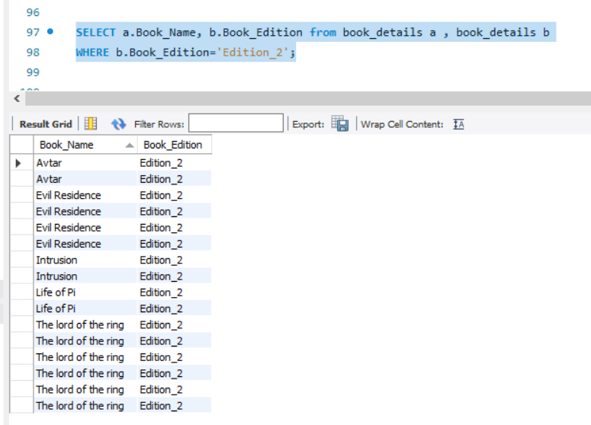

**# CROSS JOIN**

SELECT customer_name, customer_location, Book_Name FROM CUSTOMER_DETAILS CROSS JOIN book_details;

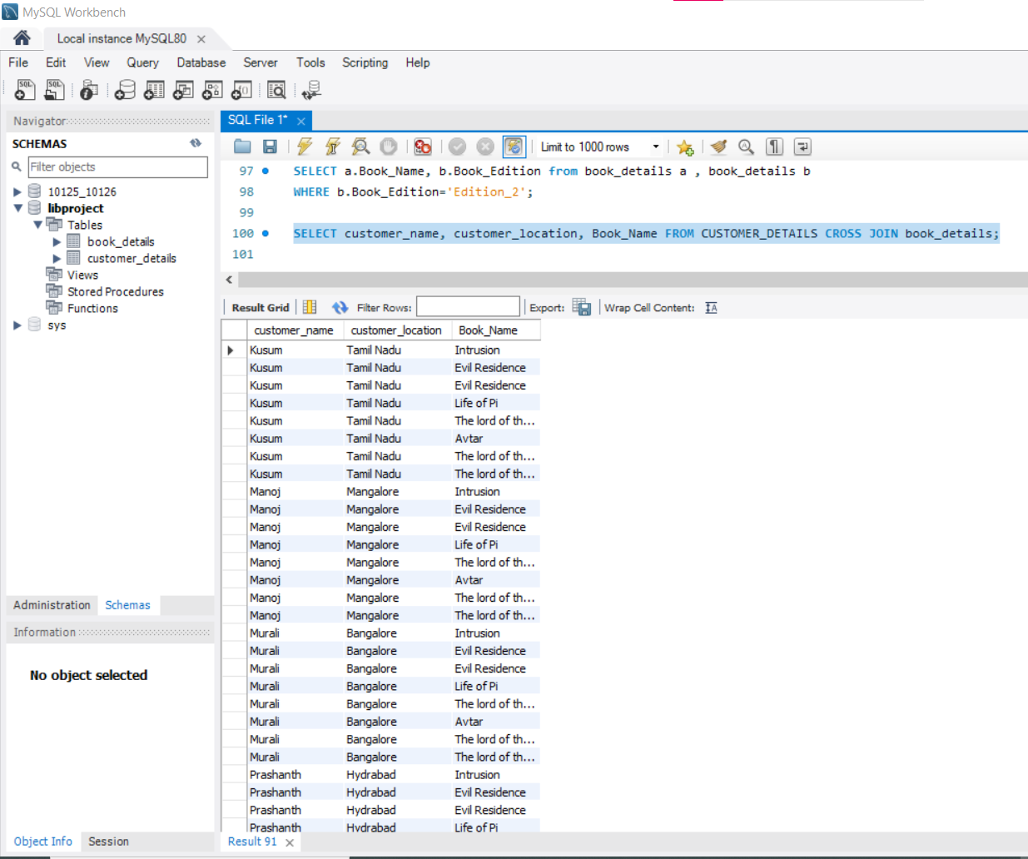

SELECT Book_Name, BOOK_CATEGORY, issue_date FROM book_details CROSS JOIN issue_status;

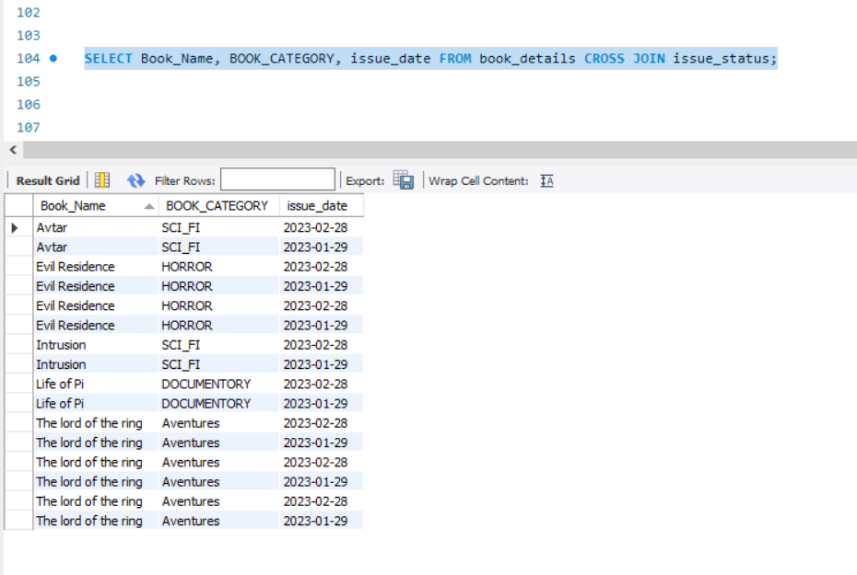

THANK YOU